**Food Delivery Problem Solving Project**

**Phase 1: Problem Understanding & IndustryAnalysis**

Problem Statement

* Food delivery businesses often face challenges like delayed deliveries, order mismatches, lack

of real-time tracking, and poor customer satisfaction.

* There is a need for a digital solution that can streamline operations, ensure transparency, and

enhance customer experience.

Project Overview

* The project aims to develop a Food Delivery Management System to address operational inefficiencies.
* It will integrate real-time order tracking, efficient delivery assignment, stakeholder management,

and smooth business workflows.

Objectives

* To create a robust food delivery platform with accurate order handling.
* To reduce delivery delays through optimized route planning.
* To improve customer satisfaction with real-time order tracking and updates.
* To enable restaurants and delivery partners to manage operations effectively.
* To explore AppExchange solutions for Salesforce-based integrations.

Requirement Gathering

* Understand customer needs (real-time tracking, multiple payment options, quick delivery).
* • Identify restaurant requirements (easy order management, integration with POS systems).
* • Define delivery partner needs (optimized routes, order notifications, earning records).

Stakeholder Analysis

* Customers: Expect timely and accurate deliveries.
* Restaurants: Need smooth order processing and revenue tracking.
* Delivery Partners: Require optimized delivery routes and fair compensation.
* Business Admins: Seek data-driven insights and system scalability.

Business Process Mapping

* Order Placement → Order Acceptance → Food Preparation → Delivery Assignment →
* Real-time Tracking → Delivery Completion.
* Identify bottlenecks such as late preparation, delivery delays, or incorrect orders.
* Map system touchpoints for automation and integration.

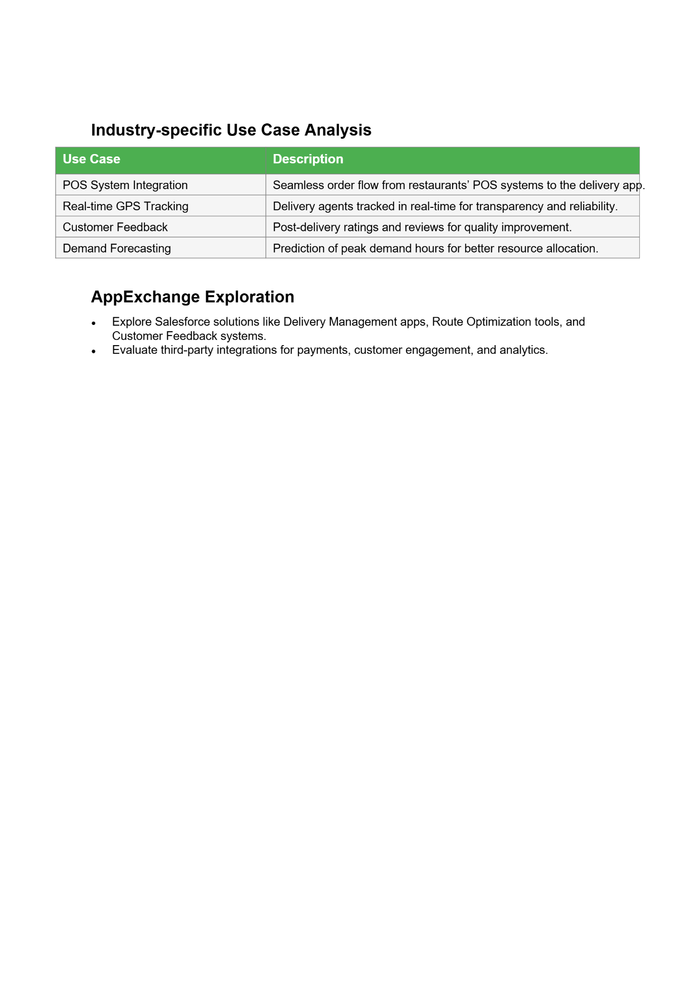

Phase 2: Org Setup & Configuration

1. Salesforce Editions

* Salesforce Editions define the features, customization level, and limits available in your Salesforce org. Choosing the right edition is crucial because it determines how you can build and scale your **Food Delivery App**.
* Edition -Features Relevant to Food Delivery App
* Developer -Free, supports full customization, ideal for prototype and testing
* Professional-Good for small-scale apps; supports custom objects, automation, reports

2. Company Profile Setup

* **Company Information:**
* Company Name: *FoodDelivery Pvt Ltd*
* Address: Relevant business location
* Primary Contact: Admin email & phone

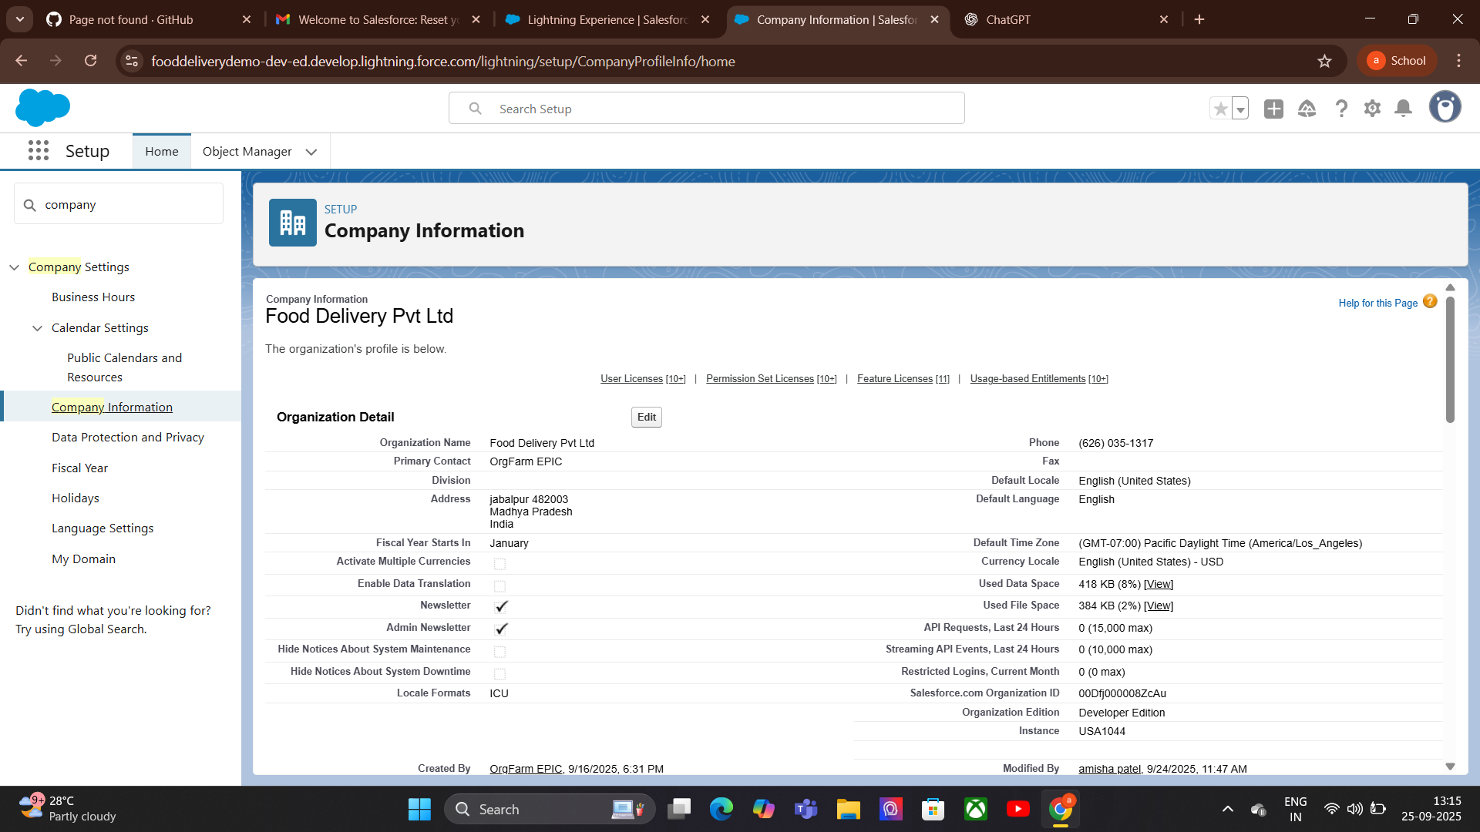

3.Business Hours:

**Purpose:** Define the hours during which your food delivery service operates to ensure accurate order processing and delivery tracking.

**Holidays:**

* Add public holidays or days restaurants are closed

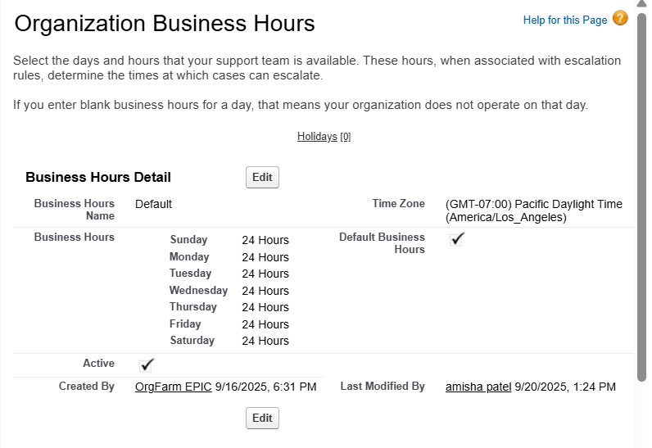

4.Ficsal Year Settings (Food Delivery App):

* Define standard (Jan–Dec) or custom fiscal year for revenue tracking

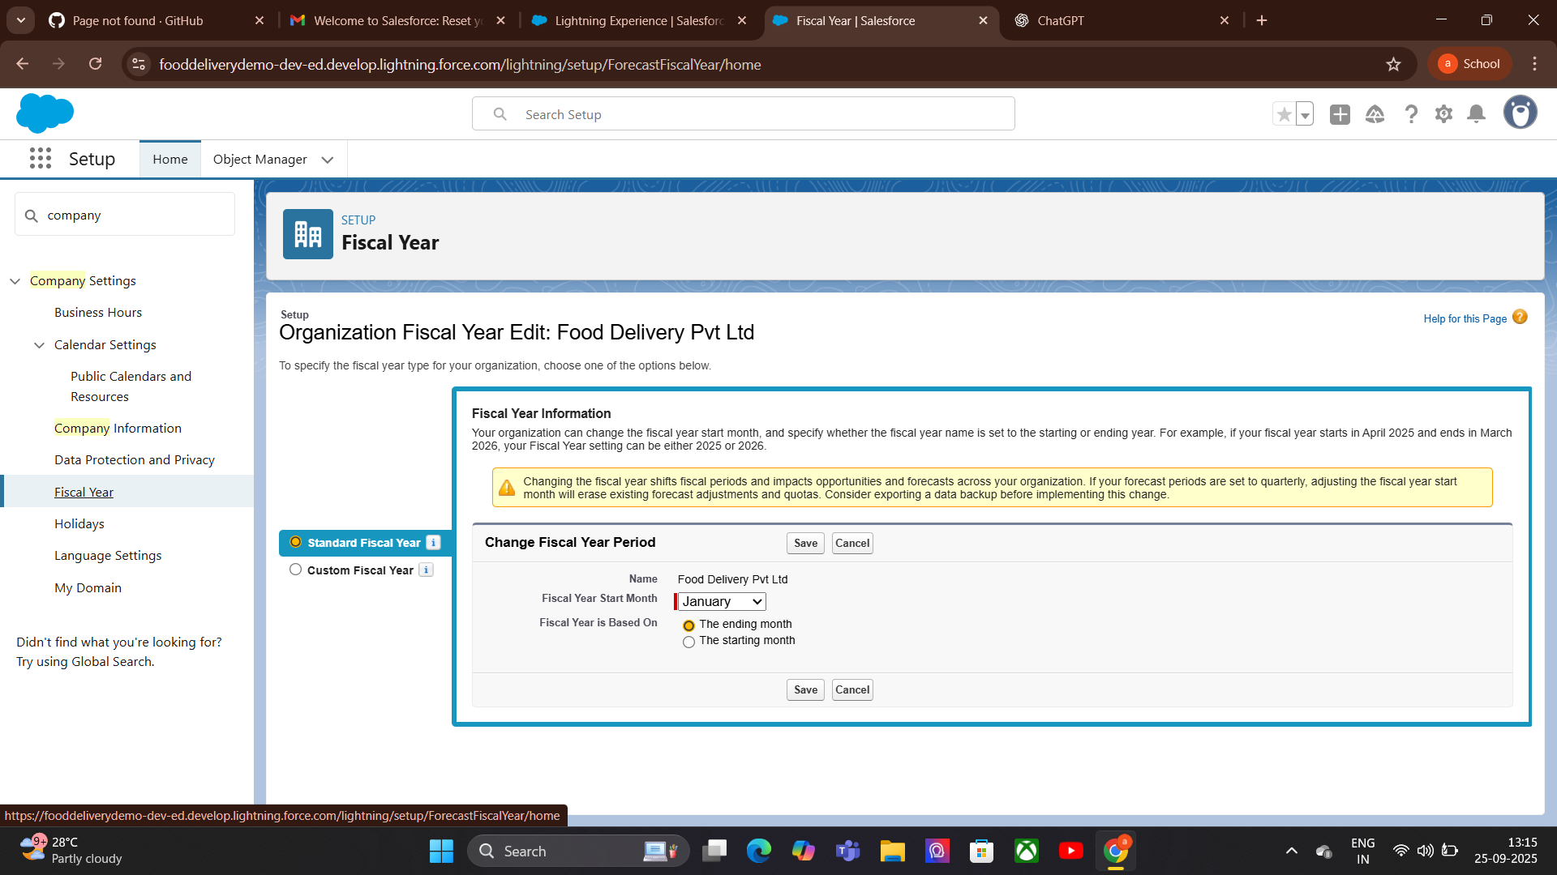

5.User setup & Licenses:

For a Food Delivery App, different users are involved:

**Customers:** View menu, place orders.  
**Restaurant Managers:** Manage orders, update menu, track delivery status.  
**Delivery Agents:** View assigned orders, update delivery status.  
**Admins:** Full access to configure the system.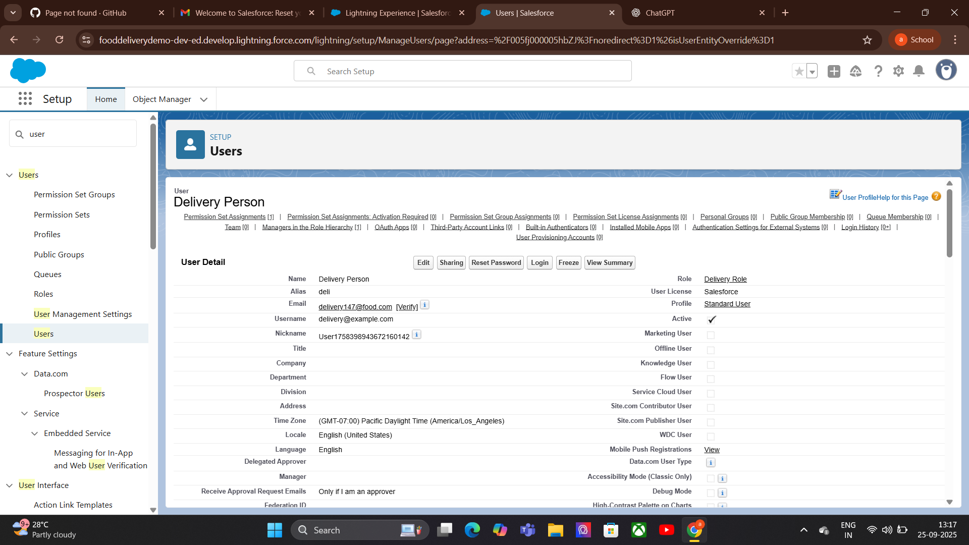

6.Profile:

### **Profiles (Food Delivery App)**

In Salesforce, a **Profile** defines a user’s permissions, access levels, and settings. It controls what a user can see and do in the system.For a Food Delivery App, profiles are important to separate access for different roles:

* **Customer Profile:** Access to order creation, order history, and menu viewing.
* **Restaurant Manager Profile:** Access to orders, menu management, reports, and dashboards.
* **Delivery Agent Profile:** Access to assigned orders, status updates, and delivery history.
* **Admin Profile:** Full access to all features, settings, and data.

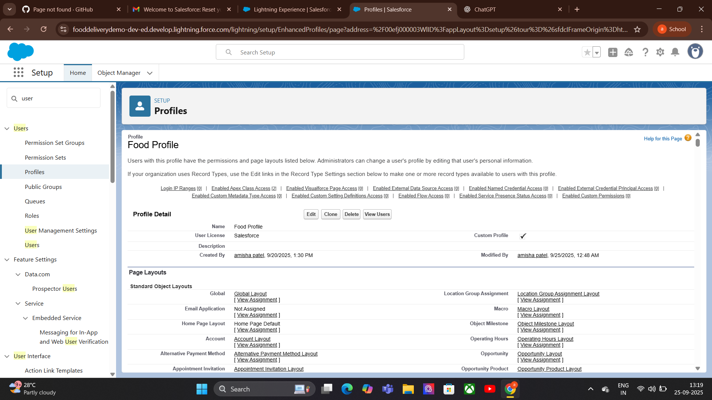

7.Roles:

### **Roles (Food Delivery App)**

In Salesforce, a **Role** defines a user’s position in the organization’s hierarchy and controls record-level access. Roles work with **Sharing Rules** to determine who can see and act on specific records.

**Admin Role, Restaurant Manager Role**,**Delivery Agent Role**,**Customer Role.**

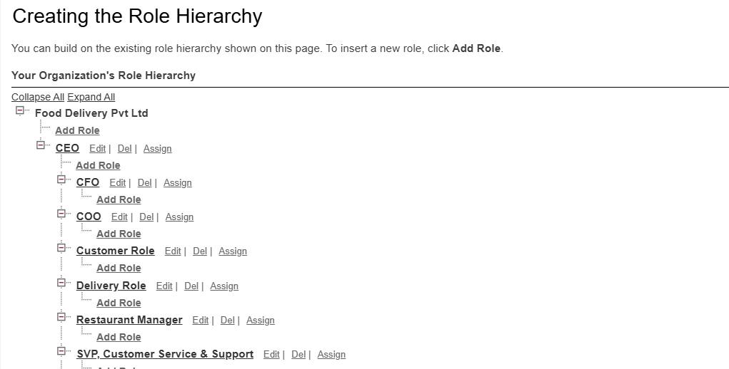

8.Permission set:

For a Food Delivery App, permission sets can be used to:

* Allow certain delivery agents to access advanced tracking features.
* Give restaurant managers extra permissions for special menu updates.

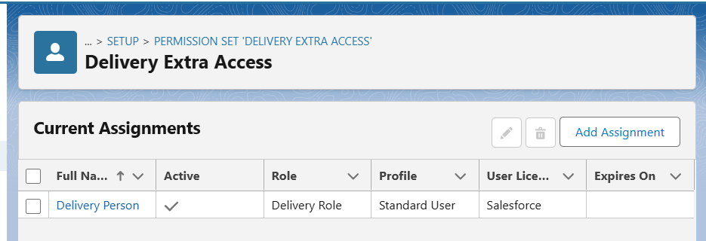

9.Owd & Sharing Rule:

**purpose:** OWD determines the baseline level of access users have to records they do not own. It’s the foundation of data security.

* Set **Menus** or **Restaurants** objects to **Public Read Only** so all users can view menus but not edit them.

**Purpose:** Sharing Rules expand access beyond OWD settings, allowing specific roles or groups to view or edit records.

* Share orders with the relevant restaurant manager role so they can manage orders for their restaurant.
* Share order details with delivery agents assigned to those orders.

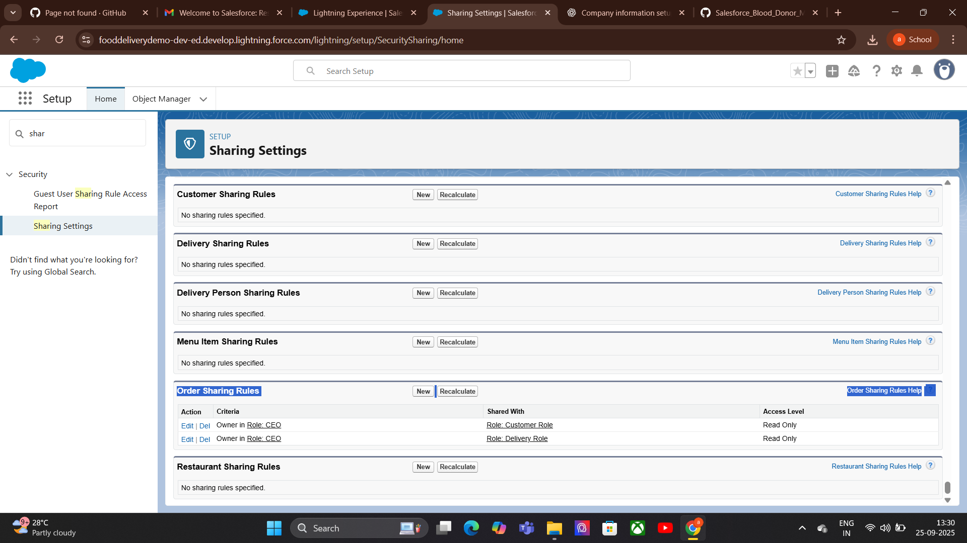  
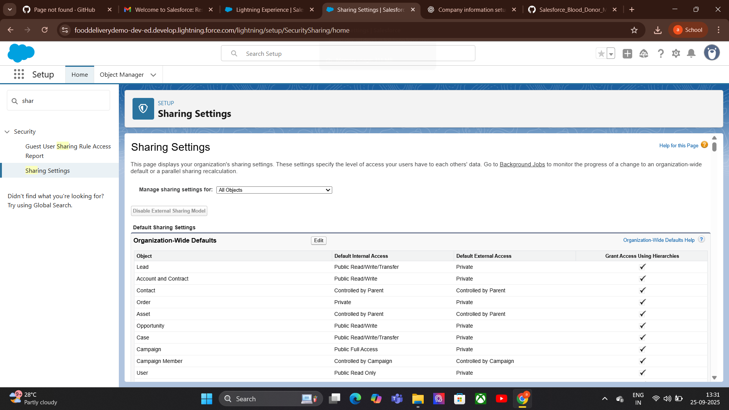

10.Login Access Policies:

**Purpose:** Login Access Policies control how and when users can log in to Salesforce. They help ensure security and manage access for different roles’

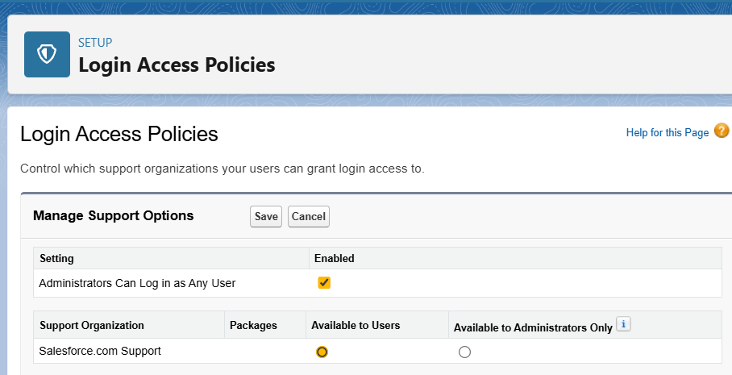

11.Dev Org setup:

**Purpose:** A Developer Org in Salesforce is a free environment used for building, testing, and learning before deploying to production. It provides full access to most Salesforce features without affecting live data.

Use **Developer Edition** to build and test objects like Orders, Restaurants, and Delivery Agents.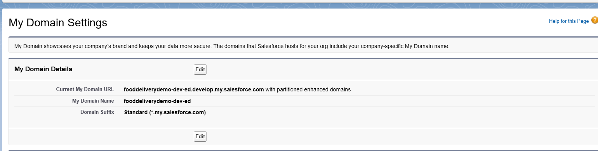

12.Sandbox Usage:

.**Developer Edition of Salesforce does NOT include full sandbox environments**.  
Developer Edition itself acts like a personal sandbox where you can build, test, and experiment  
For team development or staging, sandboxes are available only in **Enterprise, Unlimited, Performance, and Developer Pro editions**, not in Developer Edition.

13.Deployment Basic:

**Purpose:** Deployment is the process of moving changes (objects, fields, workflows, code, etc.) from one Salesforce environment to another, such as from a Developer Org or Sandbox to Production.

**For a Food Delivery App:**

**Change Sets:** Simple way to deploy from Sandbox to Production (best for small changes).  
**Salesforce CLI & Git:** Use for version control and advanced deployments.  
**Unmanaged Package:** Package all app components for deployment or sharing.  
**Testing Before Deployment:** Ensure workflows, sharing rules, and LWCs are tested in the Dev Org/Sandbox.

# 

# **Phase 3: Data Modeling &Relationships**

1.Standard & Custom Objects:

We create objects specific to food delivery:

**Custom Object Purpose**

**Order_c Store order details.**

**Menu_Item__c Store menu items for restaurants.**

**Delivery__c Track delivery assignments and status.**

**Restaurant__c tore additional restaurant info not covered by Account.**

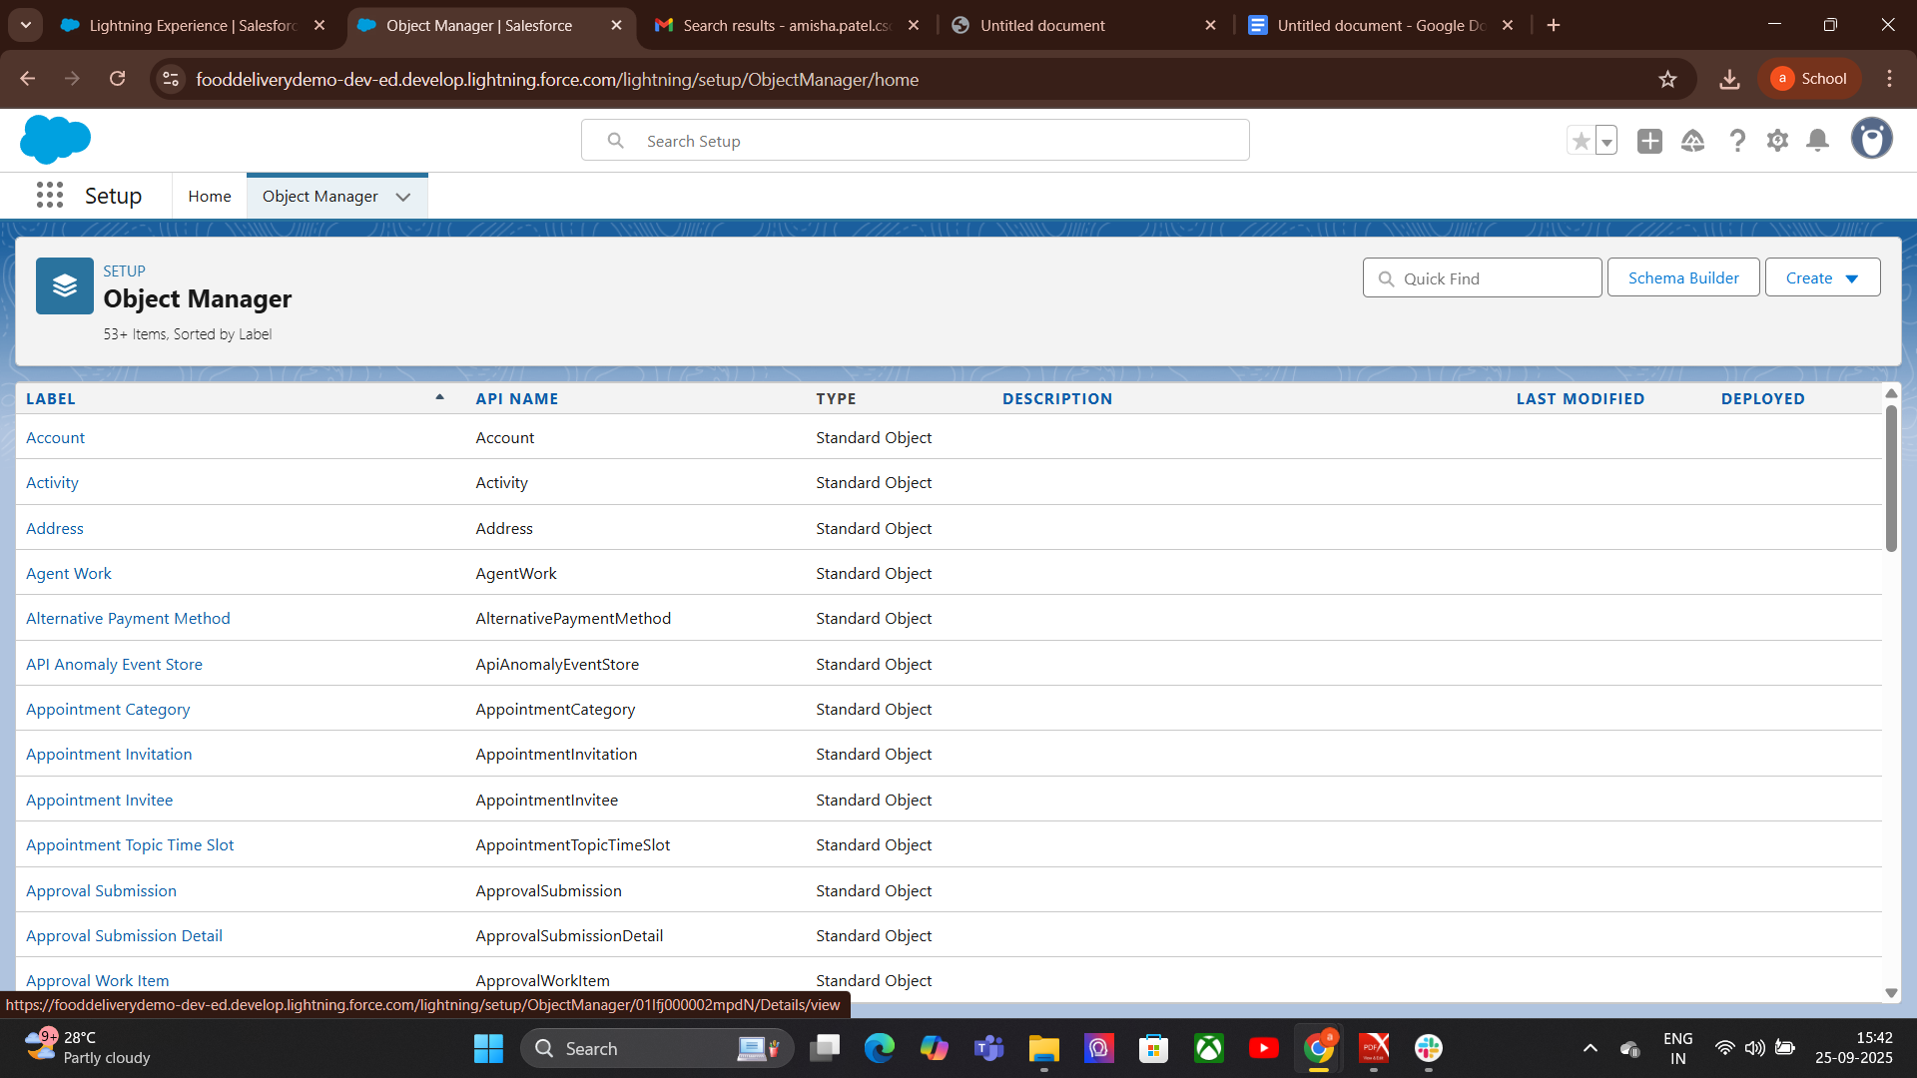

**2.Fields:**

very Object (Standard or Custom) is made up of Field

Order Number → Auto Number (e.g., ORD-0001)  
Order Date & Time → Date/Tim**e**Order Status → Picklis

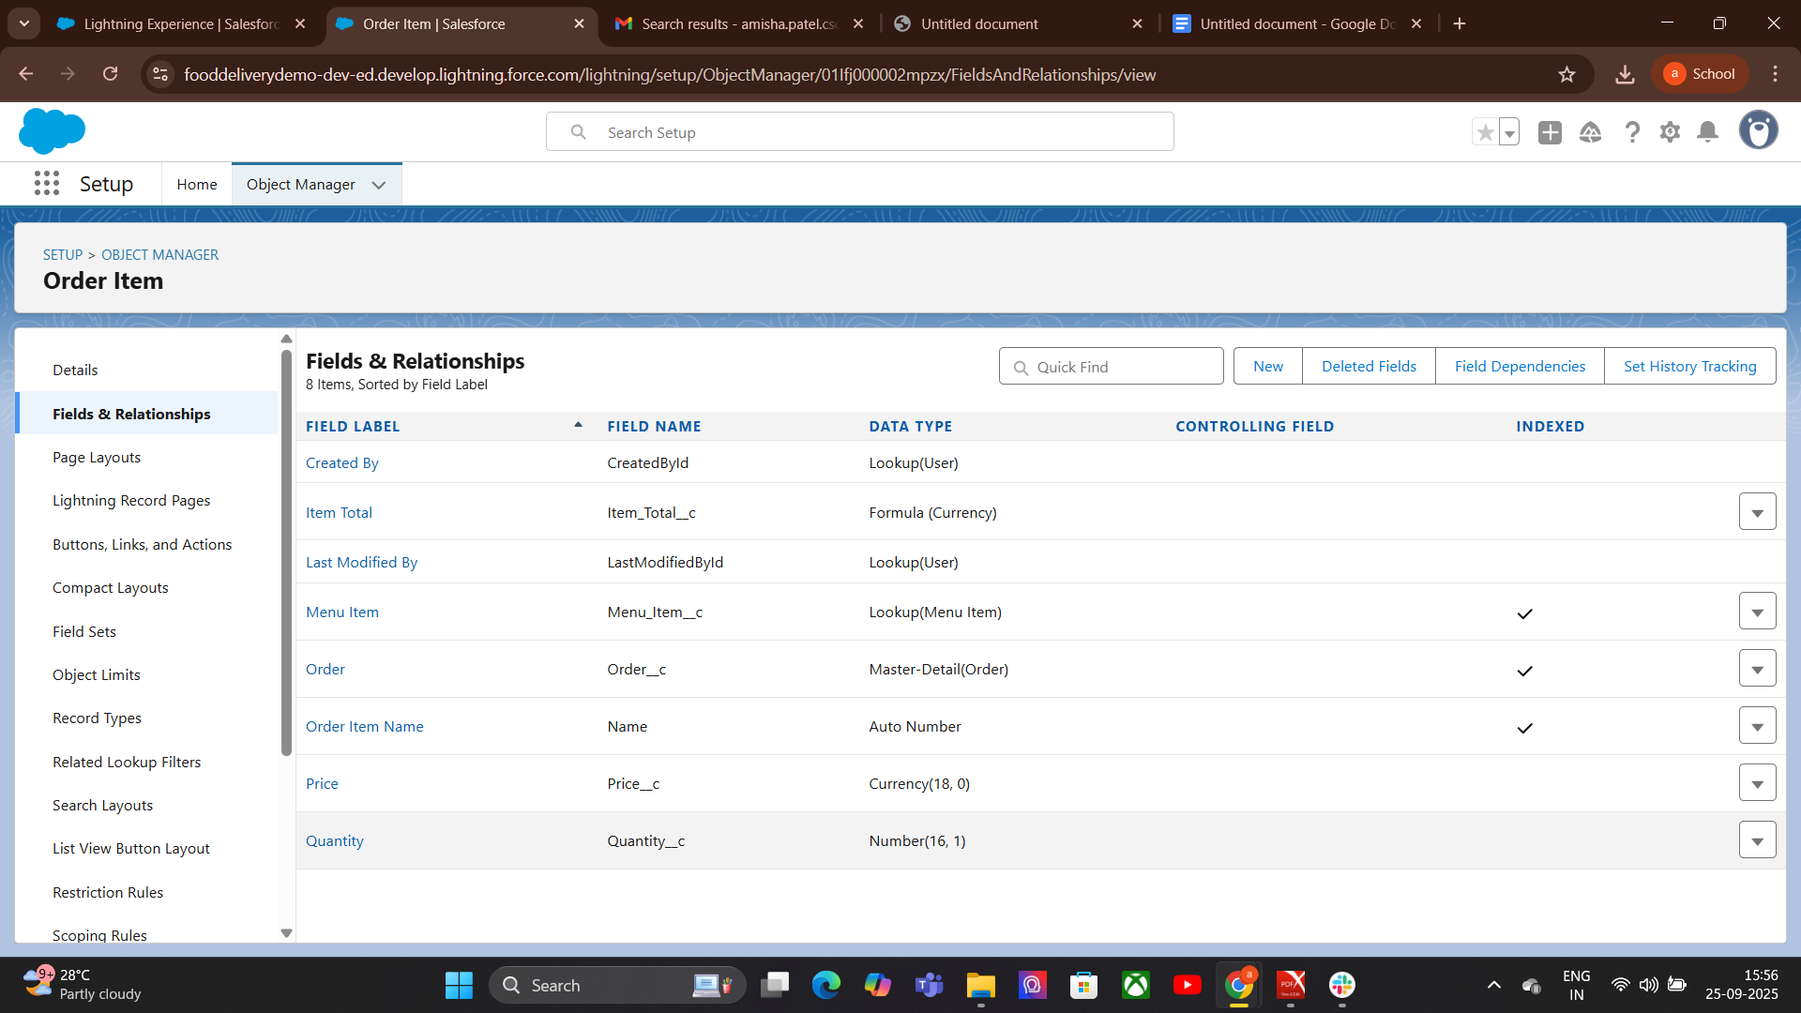

3.Record Types:

Record Types let you create different business processes within the same object.

* Dine-In Order - Fields: Table Number, Waiter Assigned.
* Deli very Order - Fields: Delivery Address, Delivery Person.
* Restaurant__c - Menu_Item__c

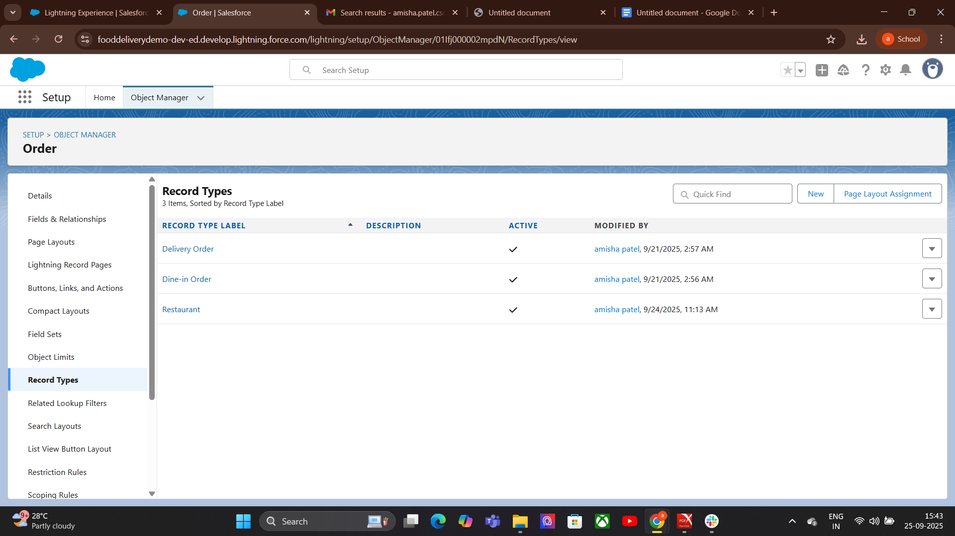

4.Page Layouts:

Purpose: Control which fields, sections, related lists, and buttons appear on a record page.

Object Manager → Object → Page Layouts → Edit Drag & drop fields, sections, related lists → Save.

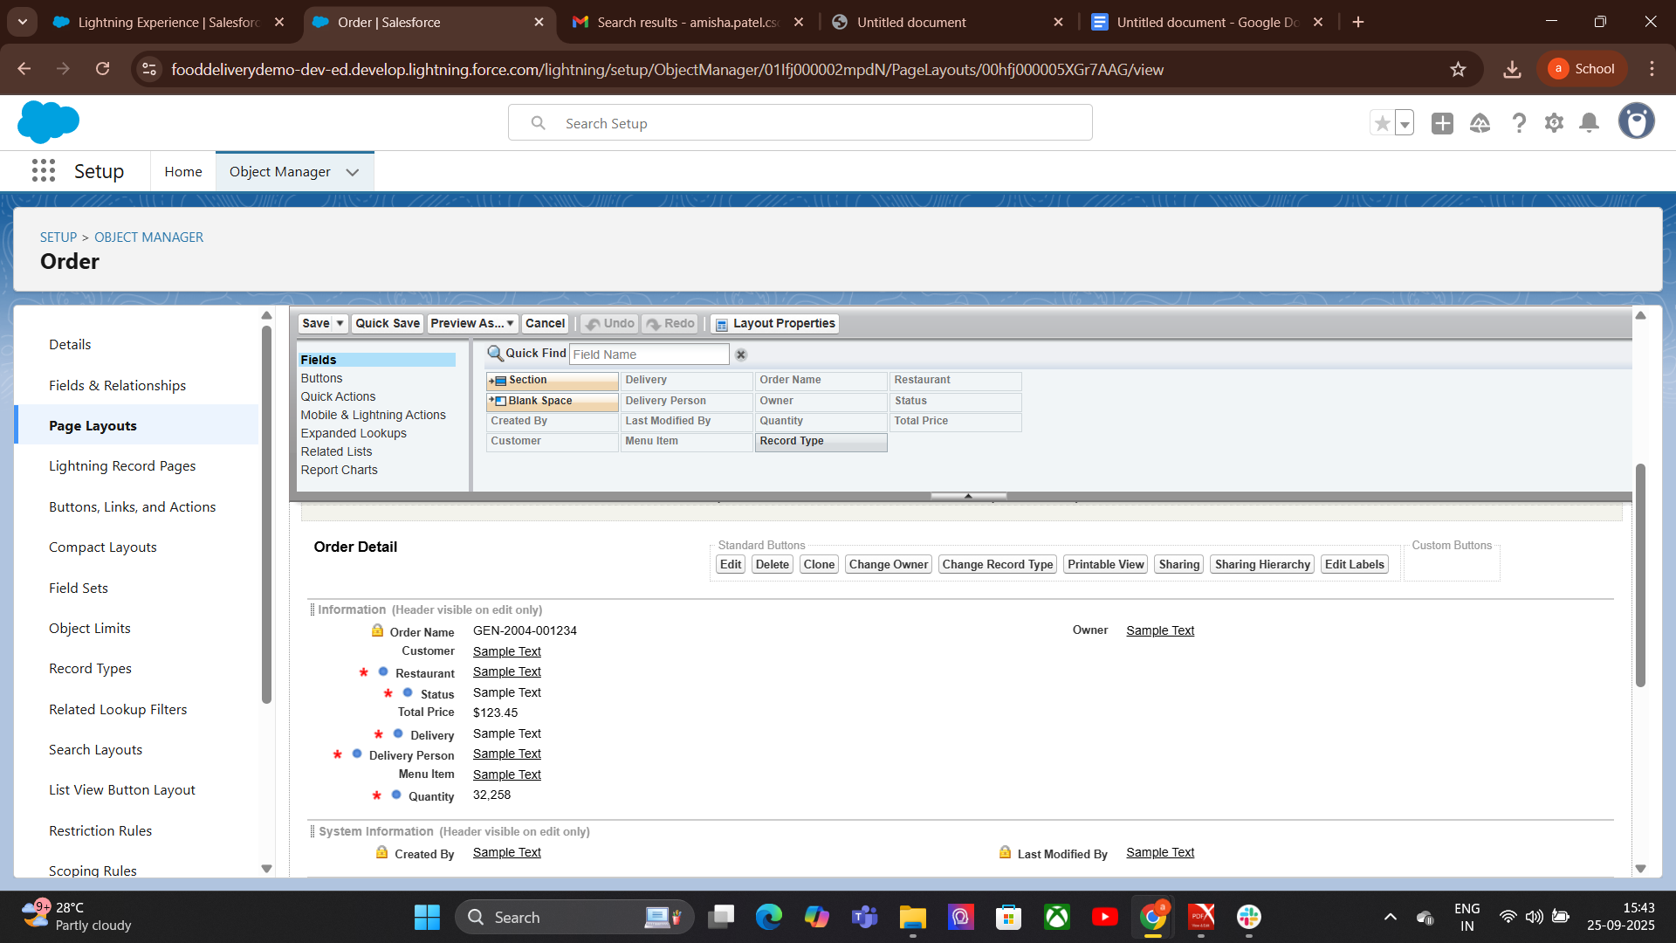

5.Compact Layout:

**How to Create/Edit a Compact Layout:**

* Go to **Setup → Object Manager**.
* Select the object (e.g., Order__c).
* Click **Compact Layouts** in the left sidebar.
* Click **New** → Enter a **Label** (e.g., “Delivery Highlights”).
* **Select up to 10 fields** to display (best practice: 4–6 fields for clarity).
* **Save.**
* **Compact Layout Assignment** → choose your layout → **Save**.

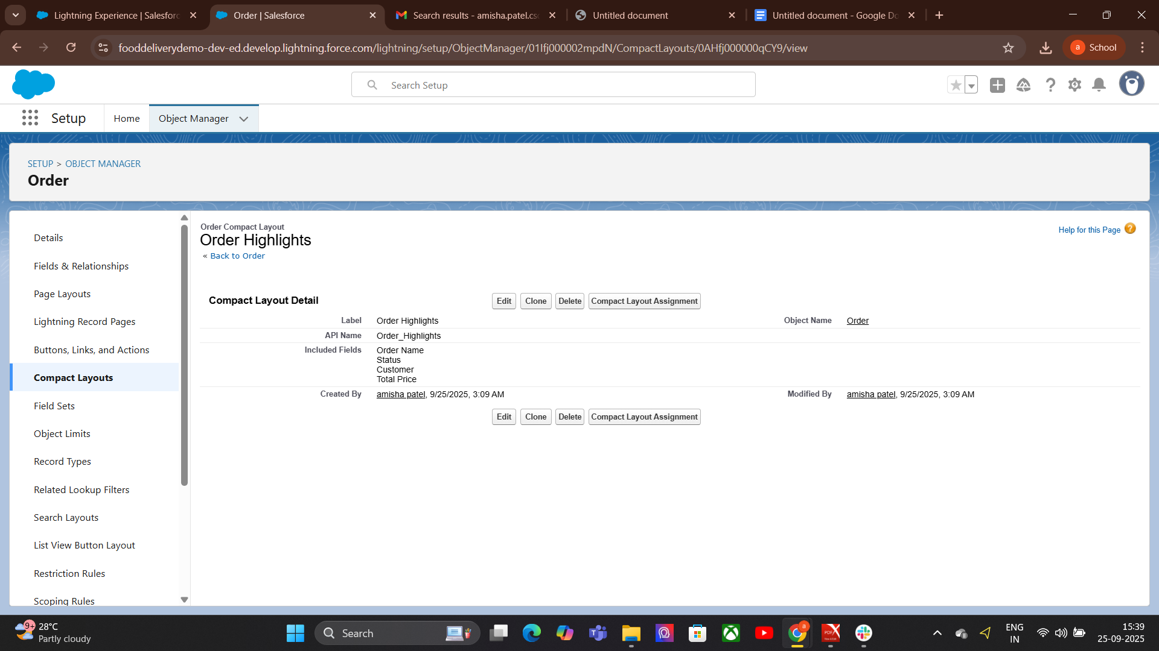

6. Schema Builder:

Schema Builder Purpose: Visual tool to see objects and their relationships. How to use:

Setup → Schema Builder

Drag objects → view fields, relationships, junction objects

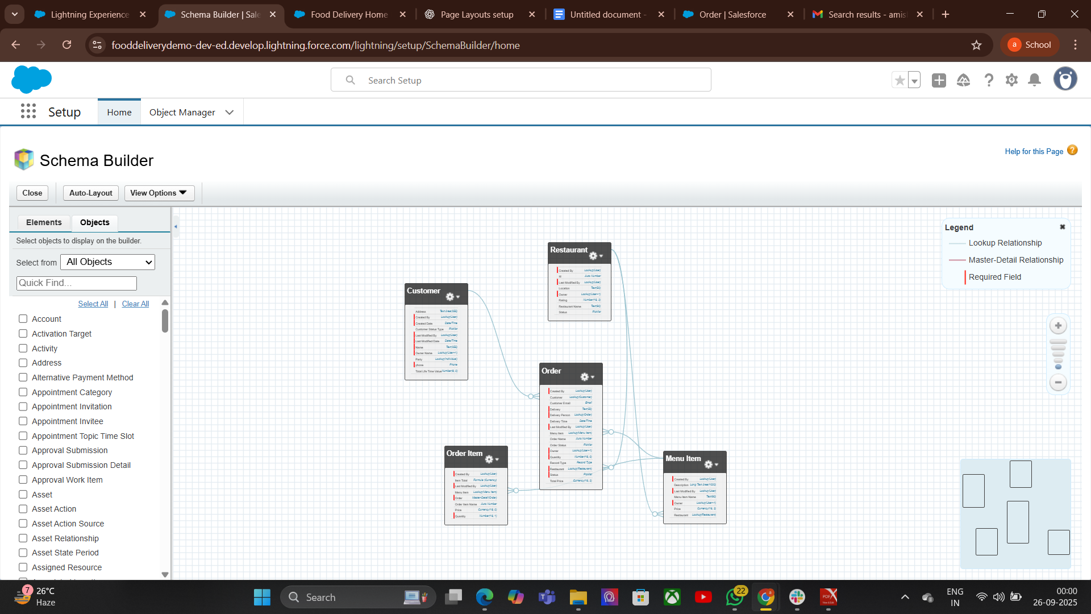

7. Lookup vs Master-Detail vs Hierarchical Relationships:

# **Lookup Relationship — step wise**

Use when you want a loose/optional link between two objects.

1. Decide: pick **Parent** (e.g., Customer__c) and **Child** (e.g., Order__c).
2. Setup → **Object Manager** → open **Child object** (Order__c).
3. **Fields & Relationships → New**.
4. **Fields & Relationships → New**.
5. Choose **Lookup Relationship** → **Next**.
6. **Related To:** select the **Parent object** (Customer__c) → **Next**.
7. Set **Field Label** (e.g., Customer) and **Field Name** → **Next**.

**Master-Detail Relationship — step wise**

Order_Item__c (junction) → Master-Detail → Order__c

Order_Item__c → Master-Detail → Menu_Item__c

**Hierarchical Relationships:**

User (Delivery Person) → Manager is another User (Team Lead).

Lets you track which Delivery Person reports to which Manager.

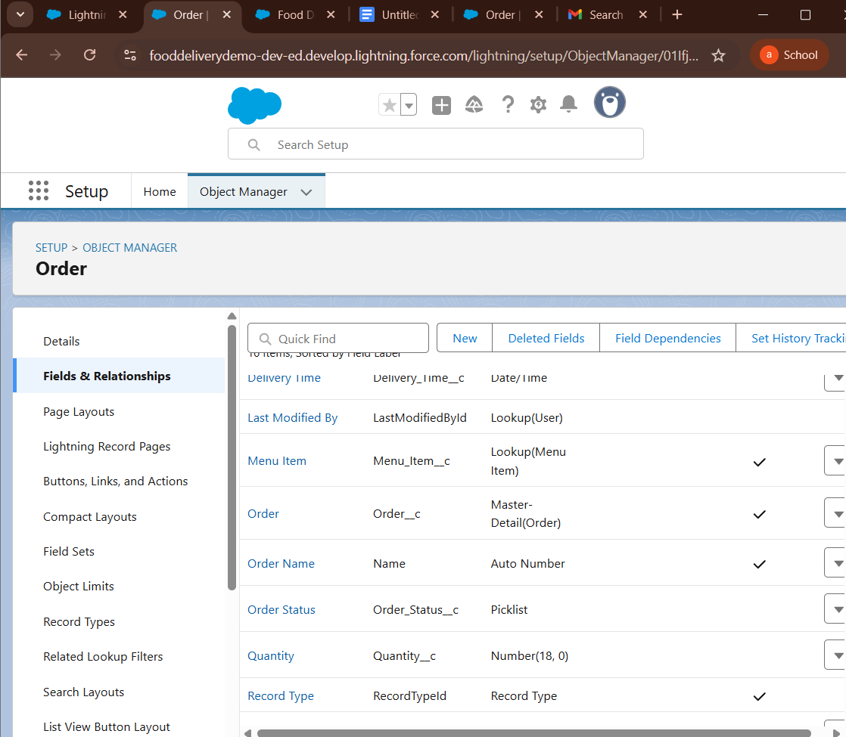  
8. **Junction Objects:**

Setup → Object Manager → Create → Custom Object → Order_Item__c (Junction).  
In Order_Item__c → Fields & Relationships → New → Master-Detail Relationship → pick Order__c → Save.  
Repeat: New → Master-Detail Relationship → pick Menu_Item__c → Save

.Add extra fields on Order_Item__c: Quantity, Price, Special Instructions.

**Test:** Create an Order and add multiple Order_Item records linking different Menu Items.

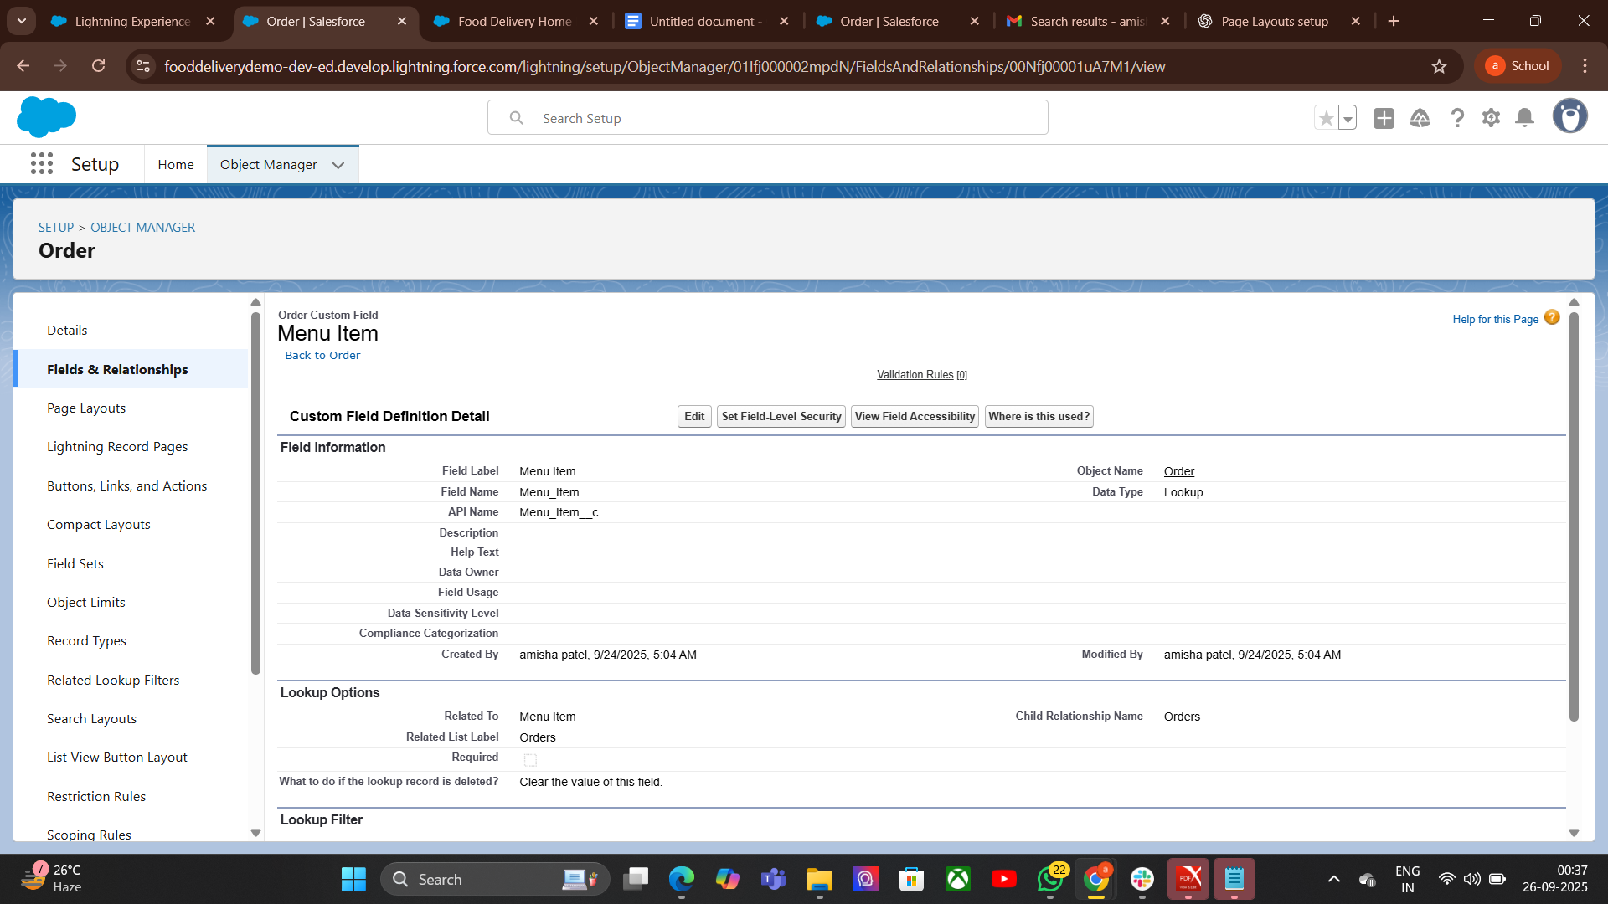

9. External Objects:

## **Step 1 — Create the External Data Source**

* Go to **Setup → Quick Find → External Data Sources**.
* Click **New External Data Source**.
* Fill in:
* **Name:** OData_Menu_Source
* **Type:** OData 4.0 (or 2.0 depending on your external API)
* Click **Save**.

## **Use External Object in App**

* Go to **App Launcher → OData_Menu_Source** tab.
* You’ll see live menu data from external system
* You can use it in reports, list views, and reference it in your Food Delivery app.

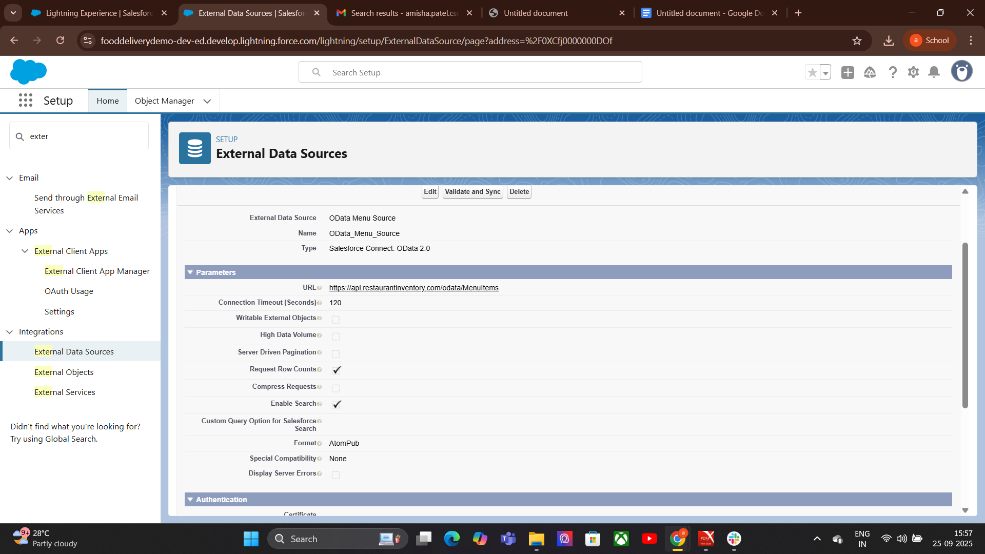

# **Phase 4: Process Automation (Admin)**

**1. Validation Rules:**

Food Delivery App ke Examples

Example 1 — Quantity must be greater than

Object: Order_Item__c  
Field: Quantity__c

Formula:

Quantity__c <= 0

**Error Message:**

Quantity must be greater than 0.

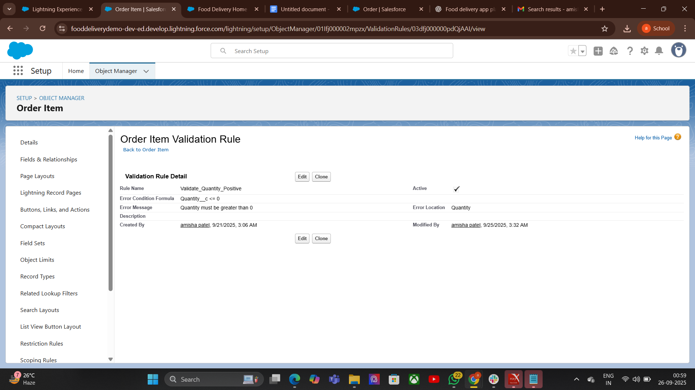

**2.Workflow Rules:**

## How to Create Workflow Rule

* Go to Setup  
  Search → Workflow Rule
* Click New Rule
* Select Object (e.g., Order__c)  
  Define Rule Criteria & Evaluation Criteria  
  Add Immediate or Time-Based Actions  
  Activate Rule

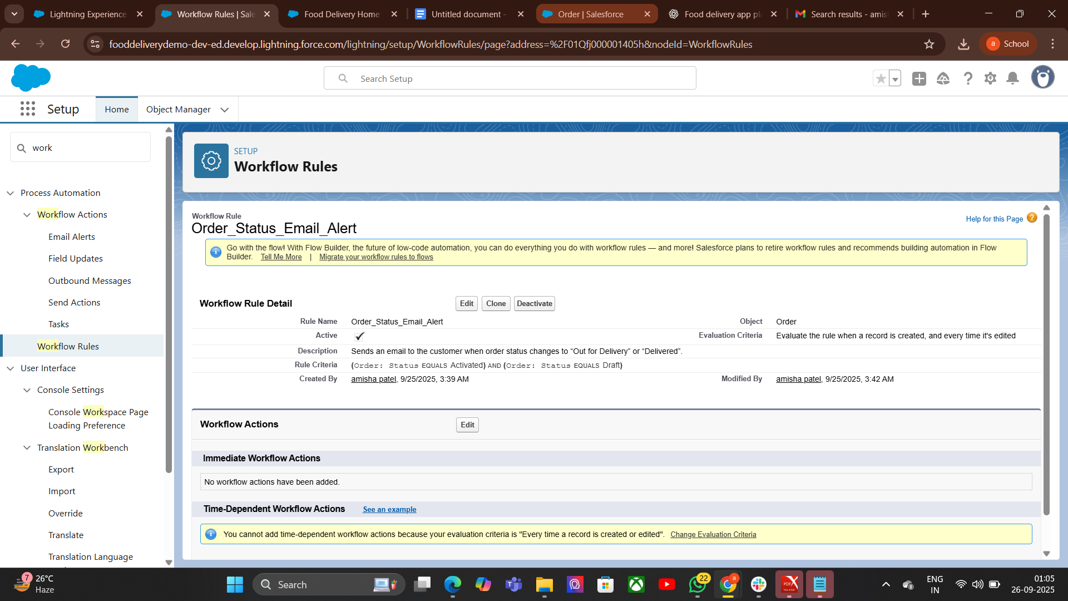

**3.Process Builder:**

## How it Works (Process Builder approach)

Go to Setup → Process Builder → New  
Give it a name: Notify Delivery Person on Order Assignment  
Choose the Order__c object

Trigger: When a record is created or edited  
Criteria:  
Immediate Actions: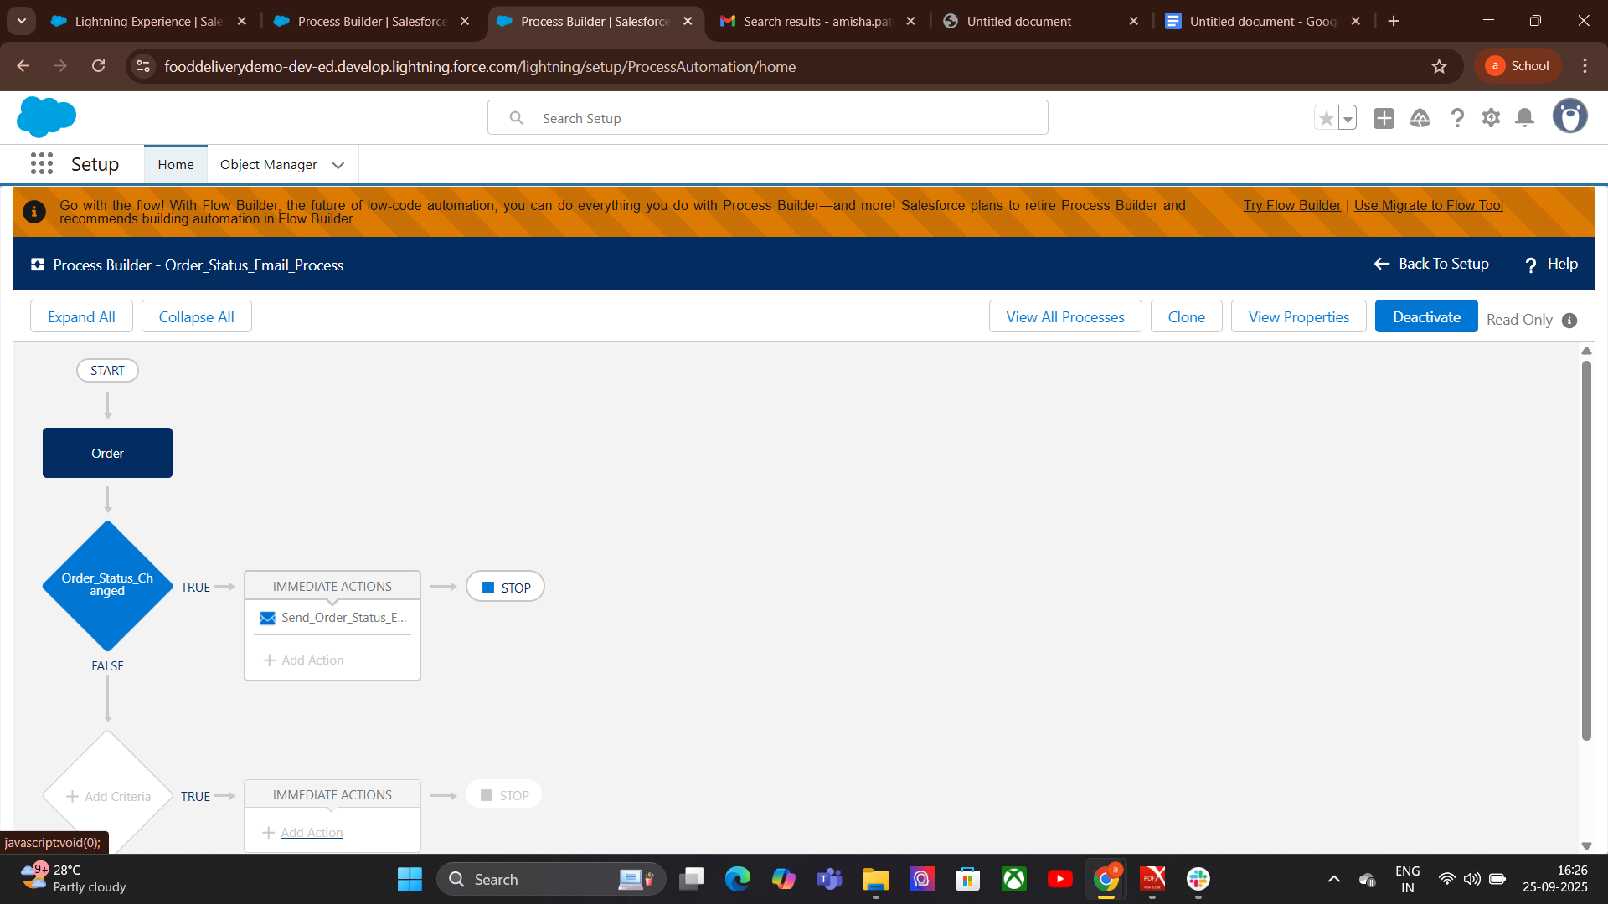

**4. Approval Process:**

## components of an Approval Process

Entry Criteria – conditions that determine which records enter the approval process  
 Approval Steps – who approves and in what order  
 Actions – what happens when a record is approved, rejected, or recalled  
 Final Approval/Rejection Actions – automated updates, notifications, field changes

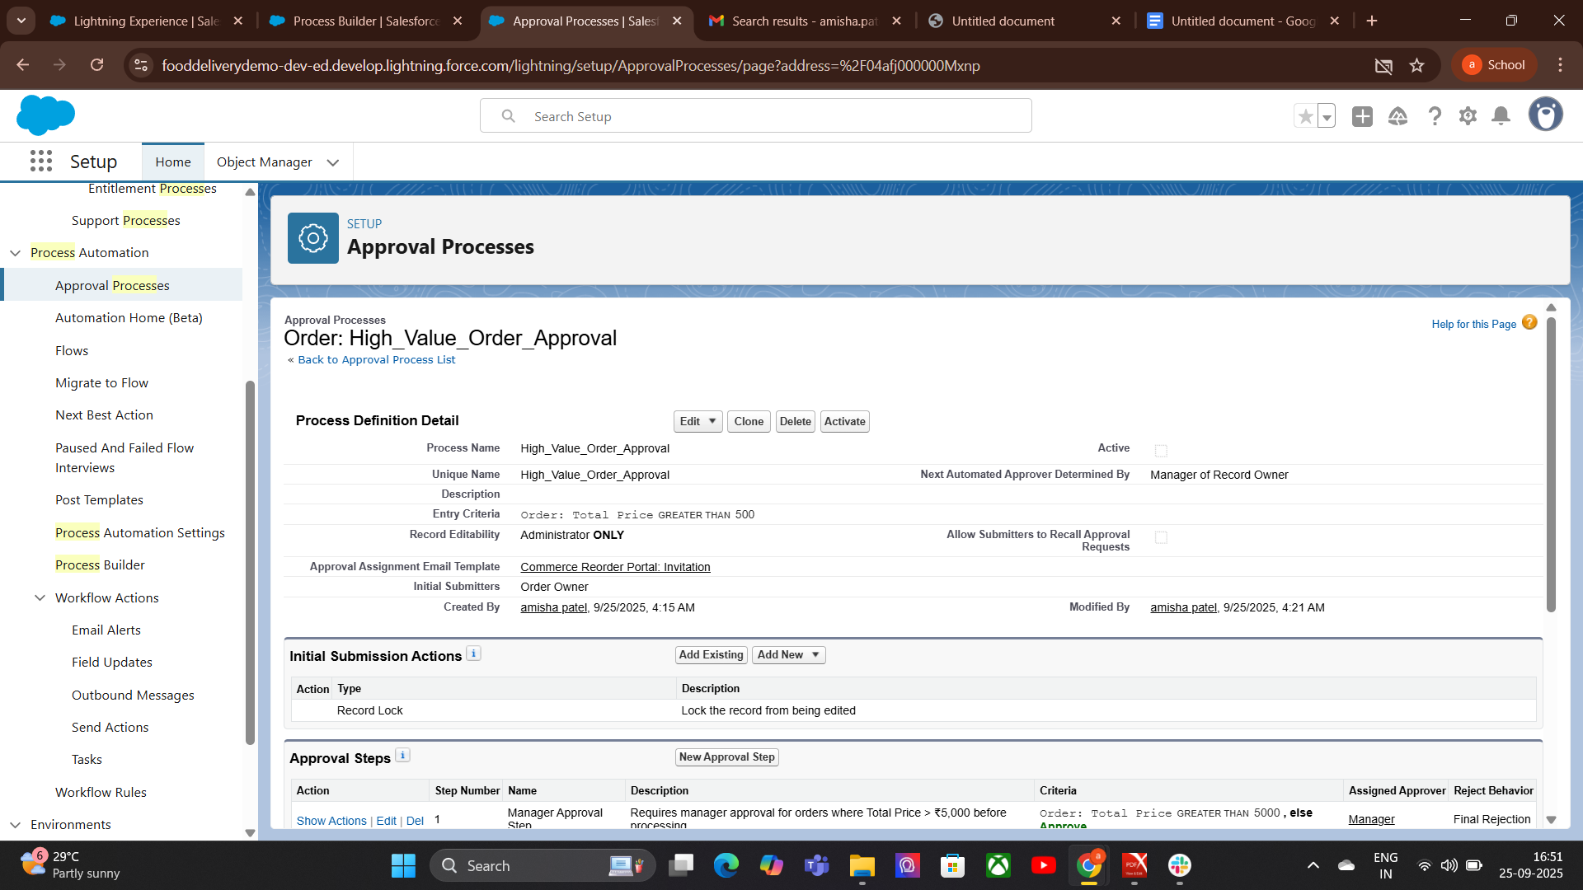

**5.Flow Builder (Screen, Record-Triggered, Scheduled, Auto-launched):**

**Screen Flow: -** Screen Flow

Purposenteractive flows that require user input.

* Use case: Guided data entry, wizards, onboarding processes.
* Key features:
* Uses screens to collect data.
* Can display UI elements like forms, choices, checkboxes.

**Record Flow: -**Purpose: Automatically runs when a record is created,   
 updated, or deleted.

* Use case: Automations tied to record changes.
* Key features:
* Runs automatically in response to record changes.
* Can run before save (fast updates) or after save (actions, notifications).
* Example: Auto-update account status when an opportunity is closed.

**Scheduled**-Purpose: Runs automatically at a specific time or recurring schedule.  
Use case: Time-based automation without human action.

* Key feature
* Runs on a schedule (daily, weekly, hourly)
* Can query records and process them in batch.

**Auto-launched Flow-**

**Purpose:** Runs in the background without user interaction.  
**Use case:** Triggered by processes, Apex, other flows, or APIs.  
 **Key features:**

* No screens or user interaction.
* Often used for backend automation

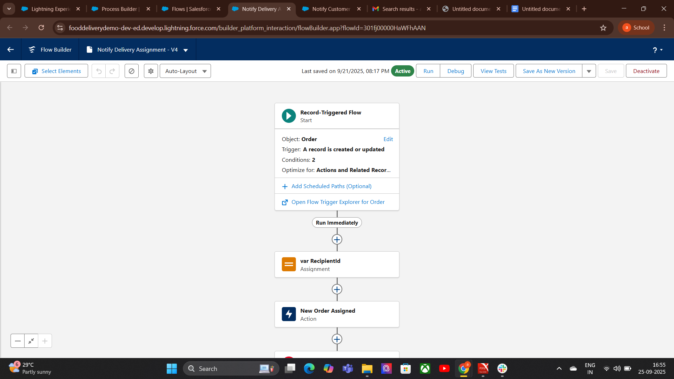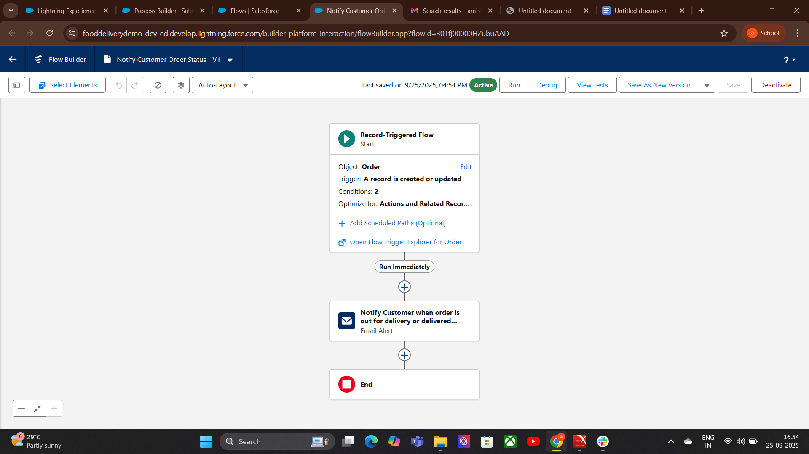

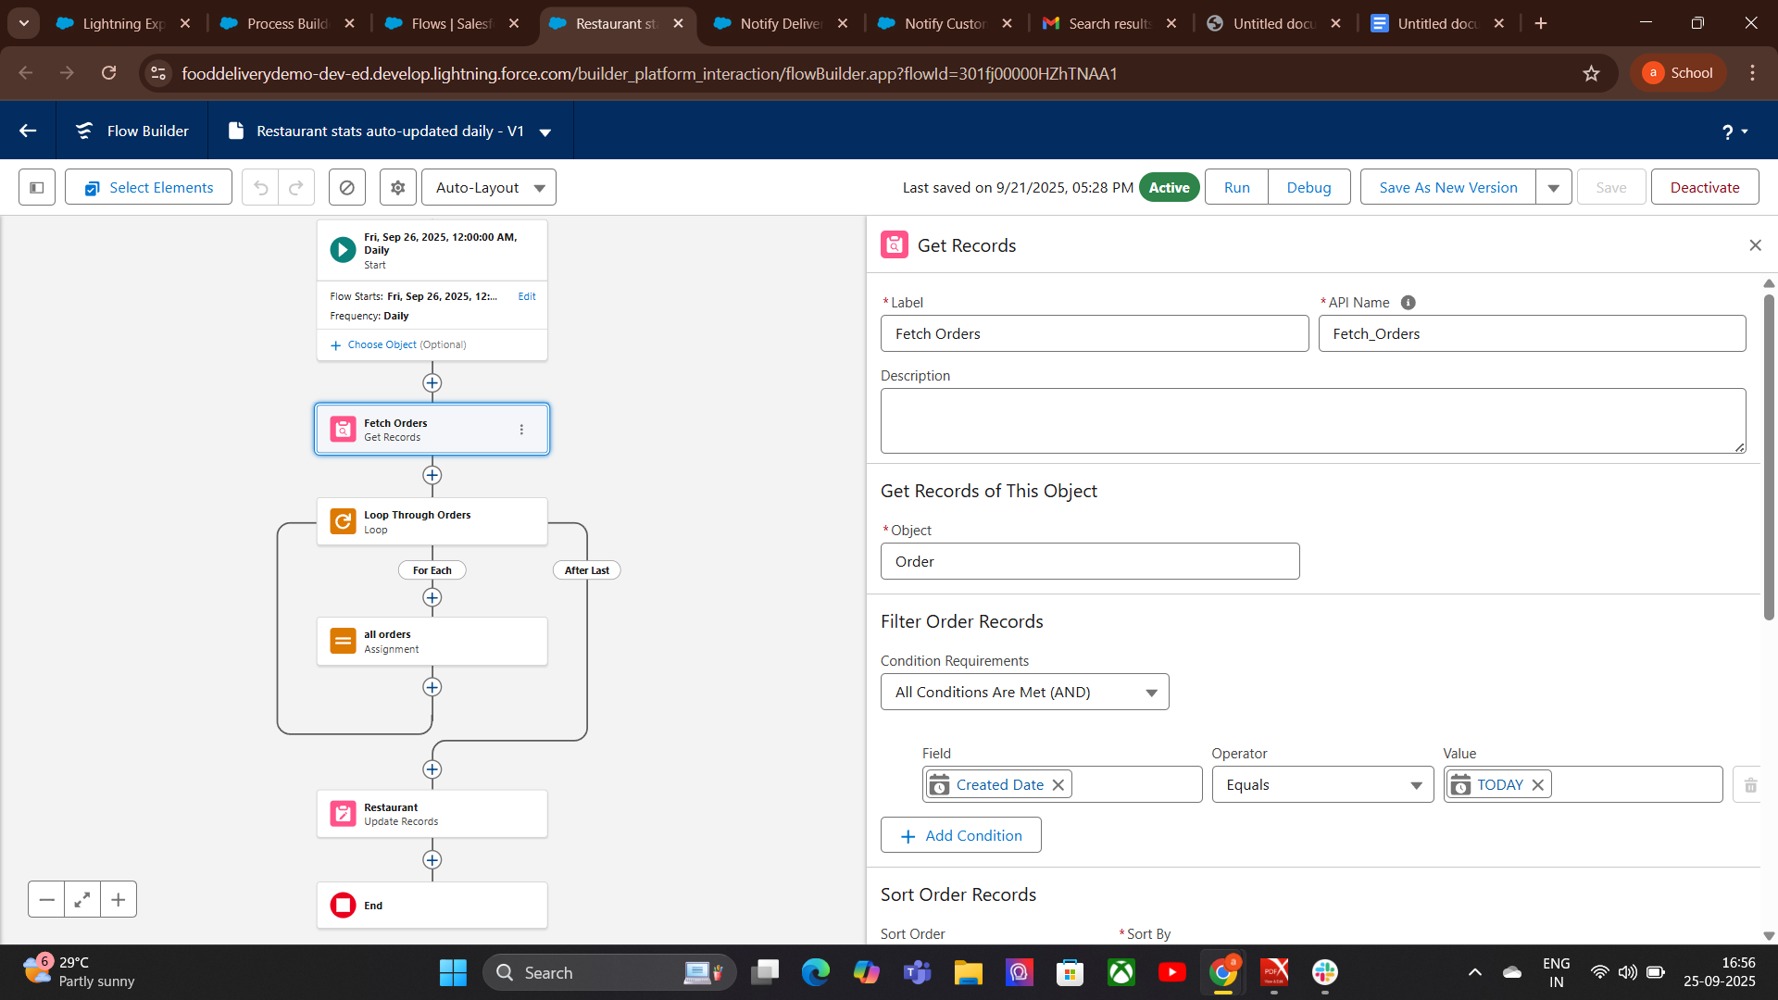

**6. Email Alerts:**

### How to Create an Email Alert

### Go to Setup → Email Alerts.

### Click New Email Alert.

### Choose:

### Email Template (design the message here first).

### Object (the record type this email will relate to).

### Recipients (users, roles, fields, groups).

### Save the email alert.

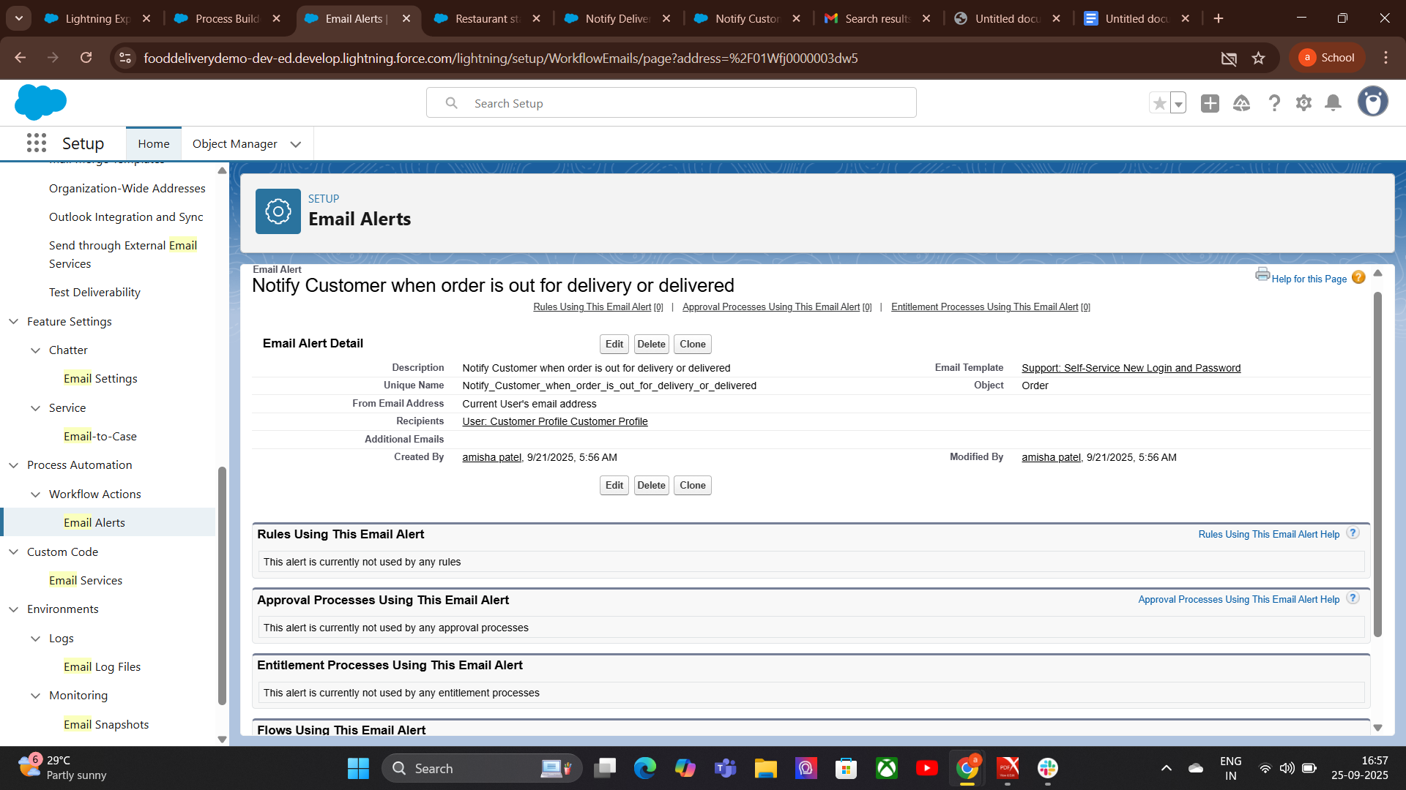

**6.Field Updates:**

Go to Setup → Workflow Rules

Select or create a **Workflow Rule** for an object.

* Add a **Field Update action**:
* Choose the field to update.
* Choose the new value:
* **A specific value** (e.g., “Closed” for Status)
* **A formula result**
* **A value from a related record**
* Save and activate.

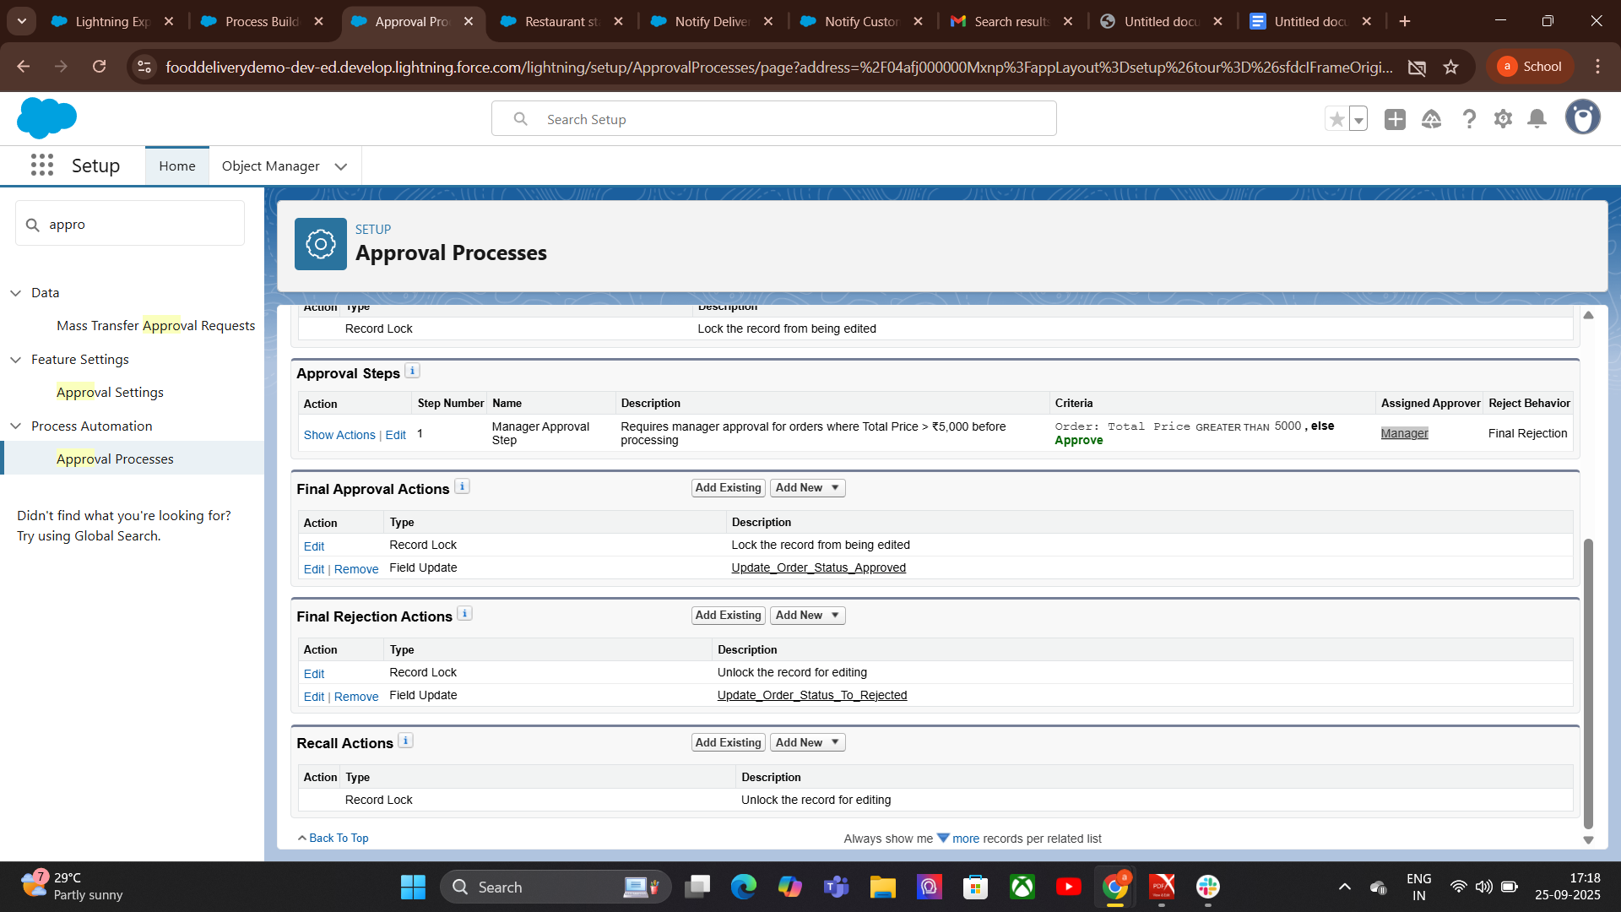

**7. Tasks:**

Automatically (Workflow/Process/Flow):

Create automation rule (workflow rule, process builder, or flow).  
Add a Create Task action.  
Define:

* + Assigned user
  + Task details (subject, due date, etc.)

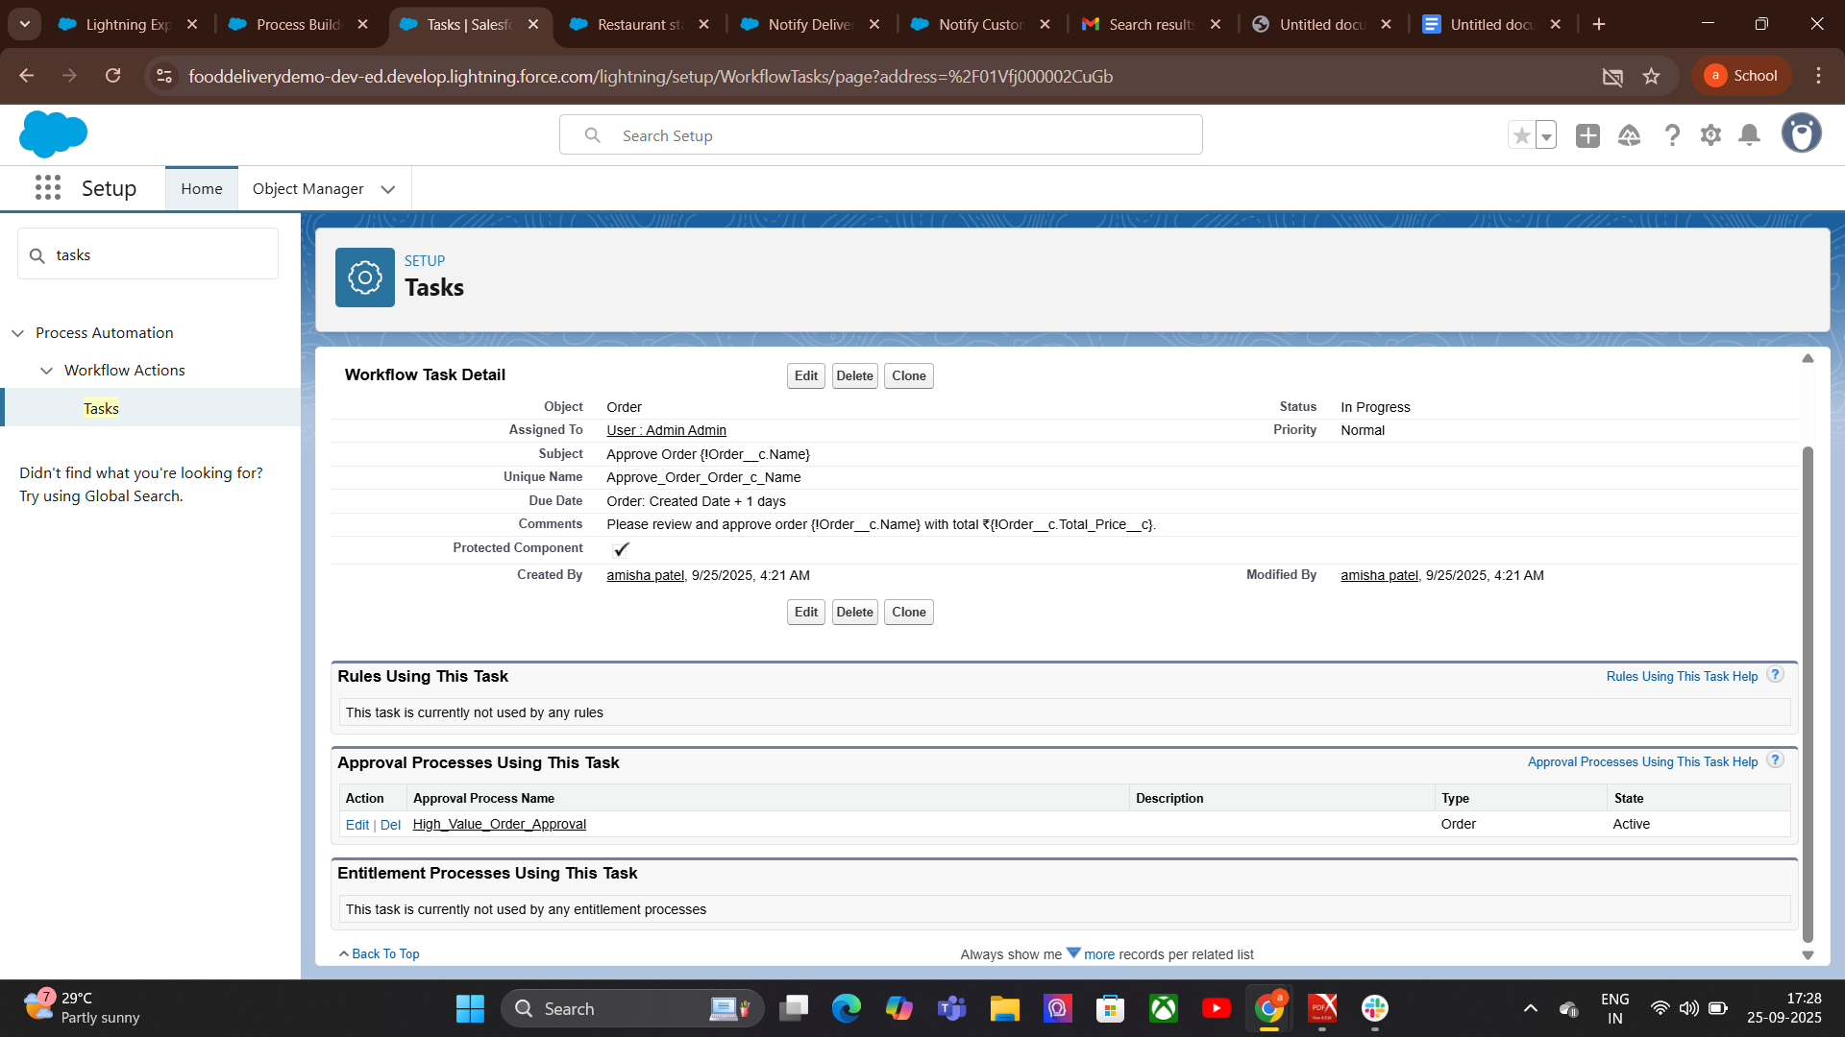

**8.Custom Notifications:**

### **How to Create a Custom Notification**

* + Create a Custom Notification Type
  + Go to Setup → Custom Notifications.
  + Click New.
  + Enter name, API name, description.
  + Choose supported channels (Desktop, Mobile, In-App)  
    Save**.**

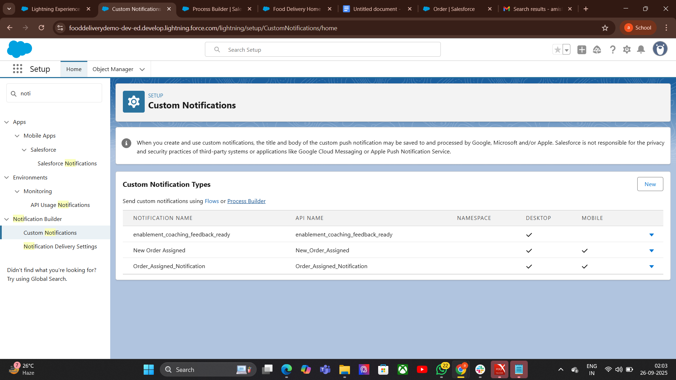

**Phase 5:Apex Programming(Developer)**

1 Classes & Objects:Steps to Create an Apex Class File

1. Open Salesforce Developer Console
   * Click your avatar → Developer Console.
2. Create New Apex Class
   * Go to File → New → Apex Class.
   * Give it a name (e.g., OrderHandler).
3. Define the Class
   * Start with public class ClassName { }.
4. Add Properties (Variables)
   * Example: orderId, customerName, totalAmount.
5. Add Constructor
6. Add Methods
7. Save the Class
8. Test the Class
9. **Check Logs -**Go to **Debug → Logs** to see the output.

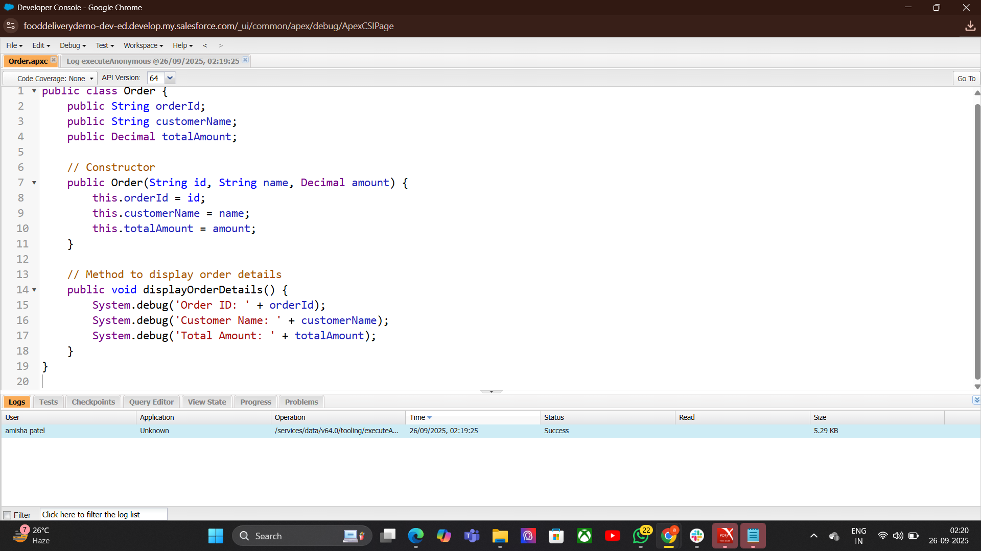

**2.Apex Triggers (before/after insert/update/delete)**

Definition: Pieces of Apex code that execute before or after records are inserted, updated, deleted, or undeleted.

**Types:**

Before Triggers: Modify data before saving (e.g., validation).

After Triggers: Access system fields or related records after saving.

Example: Automatically update a related record when an Order is inserted.

**Explanation:**

* Runs **after insert** of Order records.
* Collects related restaurant IDs.
* Updates the status of each related restaurant to "Processing".

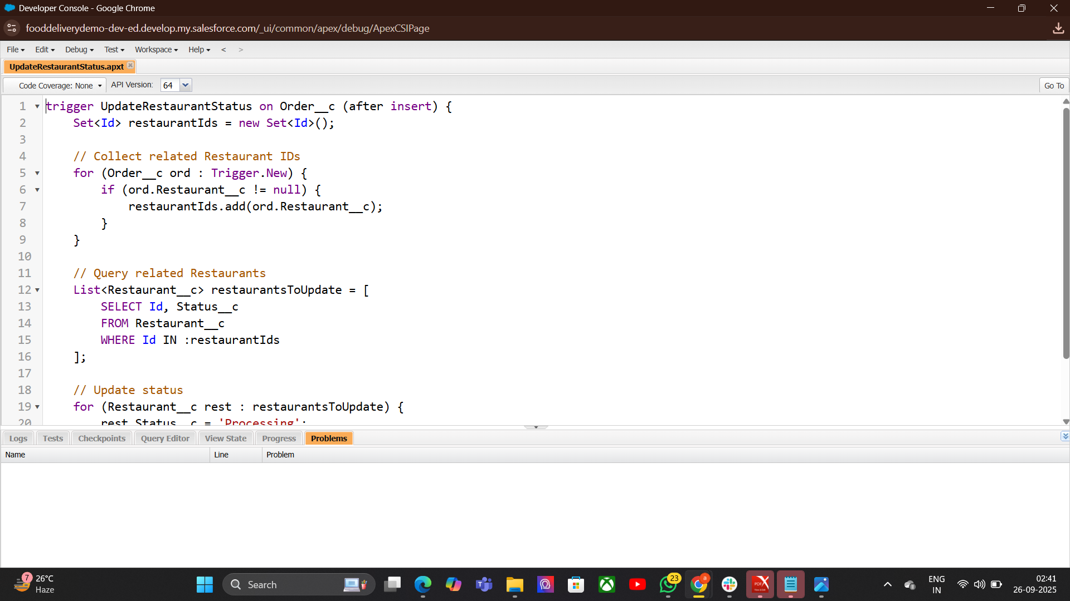

**3. Trigger Design Pattern:**

Purpose: Organize trigger logic cleanly and efficiently.

**Trigger Syntax-**

trigger TriggerName on ObjectName (events) {

// Trigger logic

}

**TriggerName** → custom name of trigger  
**ObjectName** → object   
**events** → insert, update, delete, undelete, after insert, before insert, etc.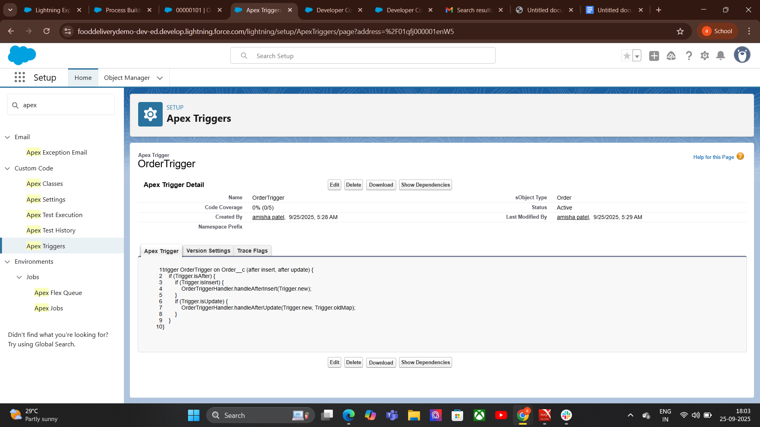

**4.SOQL & SOSL:**

### **SOQL (Salesforce Object Query Language)**

**Definition:** Salesforce’s query language that retrieves data from a single object.

* Purpose: Structured data retrieval with filtering and ordering.
* **Usage:** When you need specific records based on conditions.
* **Syntax:-SELECT fieldList FROM objectName WHERE condition.**

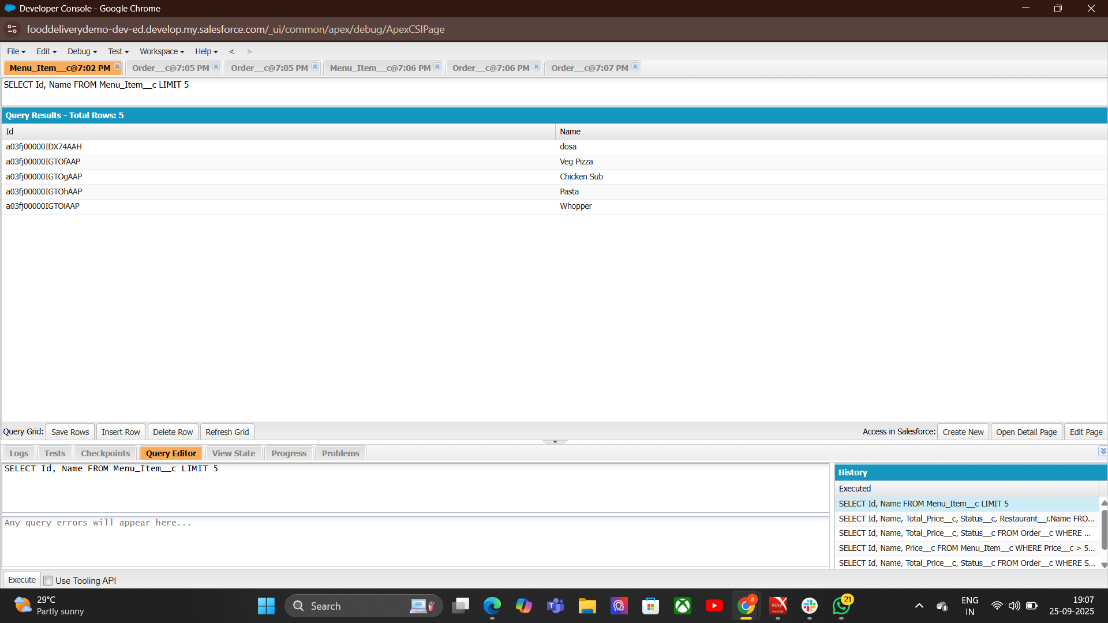

|  | **5.Collections:List,Set,Map:**  **List** Definition: Ordered collection of elements.  Purpose: Store records in a sequence.  Syntax:List<DataType> listName = new List<DataType>();  **Set**  Definition: Unordered collection of unique elements.  Purpose: Store distinct values without duplicates.  Syntax:Set<DataType> setName =new Set<DataType>();  **Map** Definition: Collection of key-value pairs.  Purpose: Store and access data by a unique key.  Syntax:Map<KeyType, ValueType> mapName = new Map<KeyType,valueType();  **5.Control Statements:**  **Control Statements** direct the flow of program execution. They include:   * **Conditional statements** (if, if...else, else if, switch) → decide which code runs based on conditions. * **Loop statements** (for, while, do...while, for-each) → repeat code until a condition is met. * **Jump statements** (break, continue) → change loop or switch flow.     **7. Batch Apex:** Basic Structure A Batch Apex class has three main methods:  start() → Prepares the query or collection to process. execute() → Processes each batch of records. finish() → Final operations after all batches are processed.    **8.Queueable Apex:**  Queueable Apex is used in Salesforce to run asynchronous jobs that allow complex processing and chaining of jobs with flexible execution. It’s like a more advanced version of Future Methods**.**  Purpose → Run long-running or resource-intensive tasks in the background.  Execution → Asynchronous, queued for execution when system resources allow.  CODE-  public class UpdateOrdersQueueable implements Queueable {  private List<Id> orderIds;  public UpdateOrdersQueueable(List<Id> orderIds) {  this.orderIds = orderIds;  }  public void execute(QueueableContext context) {  List<Order__c> orders = [SELECT Id, Status__c FROM Order__c WHERE Id IN :orderIds];  for (Order__c o : orders) {  o.Status__c = 'Processed';  }  update orders;  }  }    **9.Scheduled Apex:**  **Scheduled Apex allows you to run Apex classes at specific times or intervals automatically. It’s useful for jobs that need to run periodically without manual intervention.** **Key Points**  * Purpose → Automate processes at scheduled times. * Execution → Runs asynchronously in background at specified schedule. * Interfaces Used → Implements Schedulable interface. * Flexibility → Can schedule daily, weekly, monthly, or custom times.     **10. Future Methods:**  Future methods are asynchronous Apex methods that run in the background at a later time. They are useful for tasks that don’t need to run immediately, such as external callouts or bulk processing. Class Name OrderEmailSender → A helper class to send order confirmation emails asynchronously.    **11. Exception Handling:** Key Points  * Purpose → Handle runtime errors and maintain program stability. * Types of Exceptions →      * + System Exceptions → Built-in errors (e.g., NullPointerException, DmlException).   + Custom Exceptions → User-defined errors for special scenarios. Keywords Used → try, catch, finally, throw. |
| --- | --- |
|  |  |
|  | **12.Test Classes:**   * Creates Test OrdersIt creates a list of 5 orders with the status "Draft".   + These are inserted into the database. * Runs the Method Under Test   + I tcalls OrderExceptionHandler.processOrders() inside Test.startTest() and Test.stopTest().   + This ensures testing is done in a fresh context and respects governor limits. * Verifies the Results It queries the orders back from the database. It checks that each order’s status is now "Activated" using System.assertEquals. |
|  |  |

# **Phase 6: User Interface Development**

**1.Lightning App Builder:**

Lightning App Builder is a point-and-click tool in Salesforce that lets you create custom pages for the Lightning Experience and mobile app without writing code.

### Steps to Use Lightning App Builder

### Go to Setup → Search for *Lightning App Builder*.

### Click New.

### Select page type (App Page, Home Page, Record Page, etc.).

### Choose a template layout.

### Drag and drop components onto the canvas.

### Configure component properties.

### Save and activate the page (set for org, app, or profile-specific visibility).

### **2. Record Pages:**

## How to Create a Record Page:

* Go to Setup → Lightning App Builder.
* Click New → Record Page.
* Select object (e.g., Order__c).
* Name it (e.g., “= record Order Page”).
* Choose a layout template.
* Drag & drop standard/custom components.
* Save and Activate → Choose activation rules (Org Default, App Default, or Profile-specific).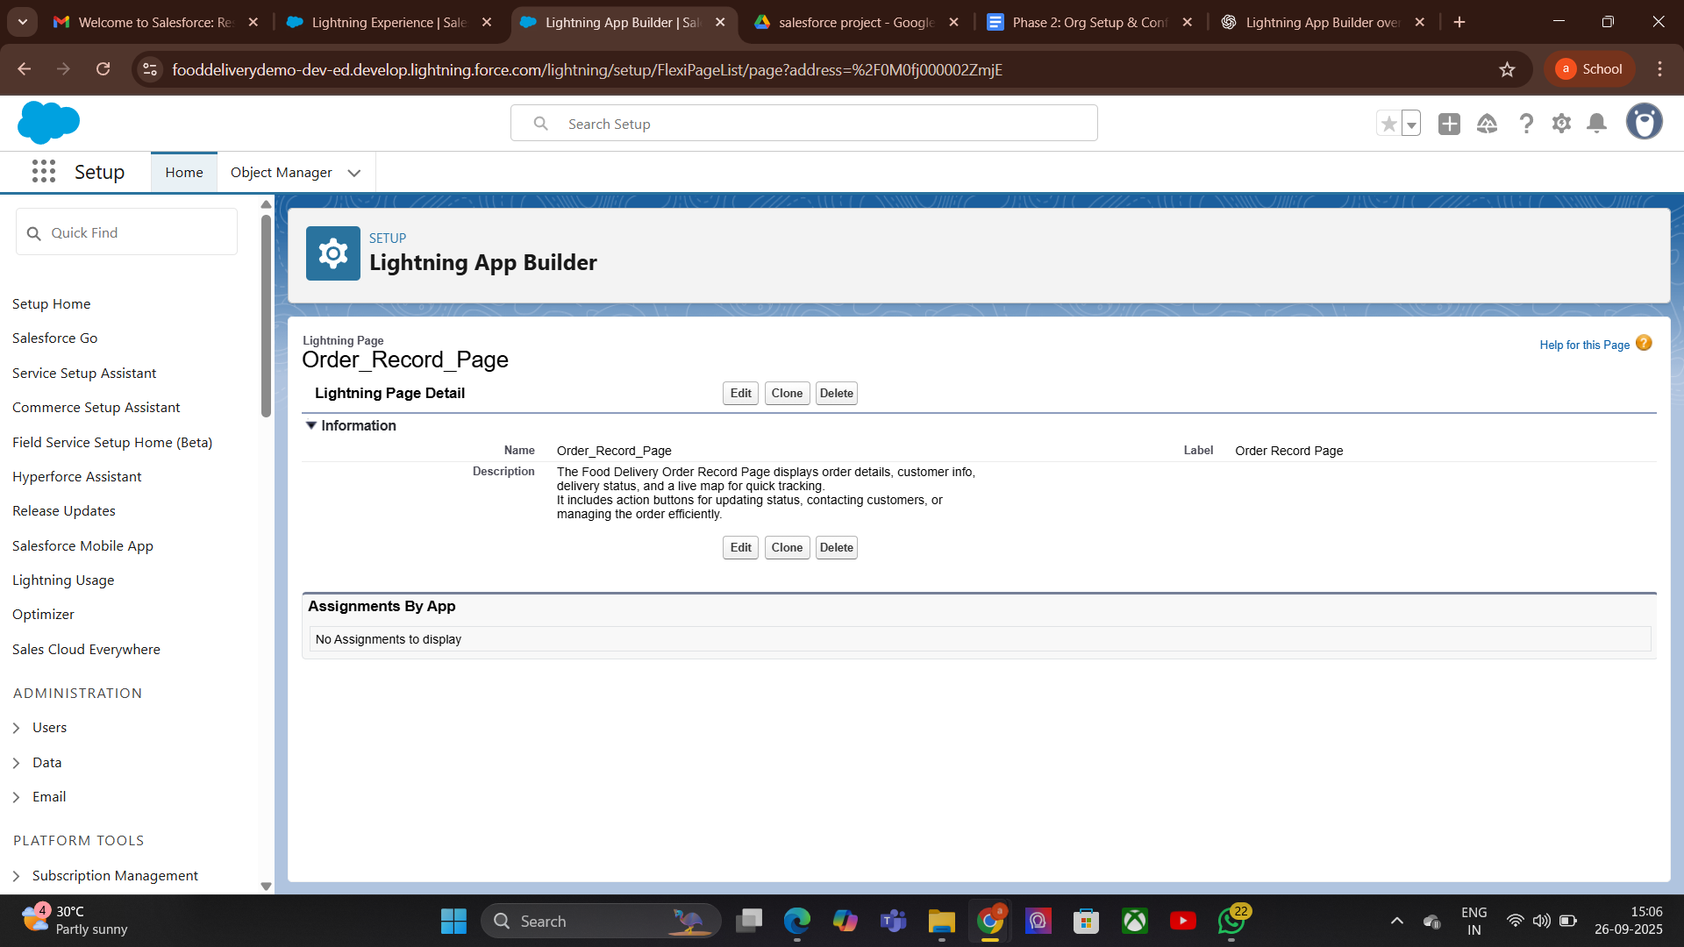

**3. Tabs:**

Tabs in Lightning App Builder are sections within an app or page that organize content into separate, easy-to-access areas.

Tabs could be:

* **Delivery Persons** – People who deliver orders.
* **Deliveries** – Records of orders and their status.
* **Menu Items** – Food items offered by restaurants.
* **Restaurants** – Places that prepare and sell food.

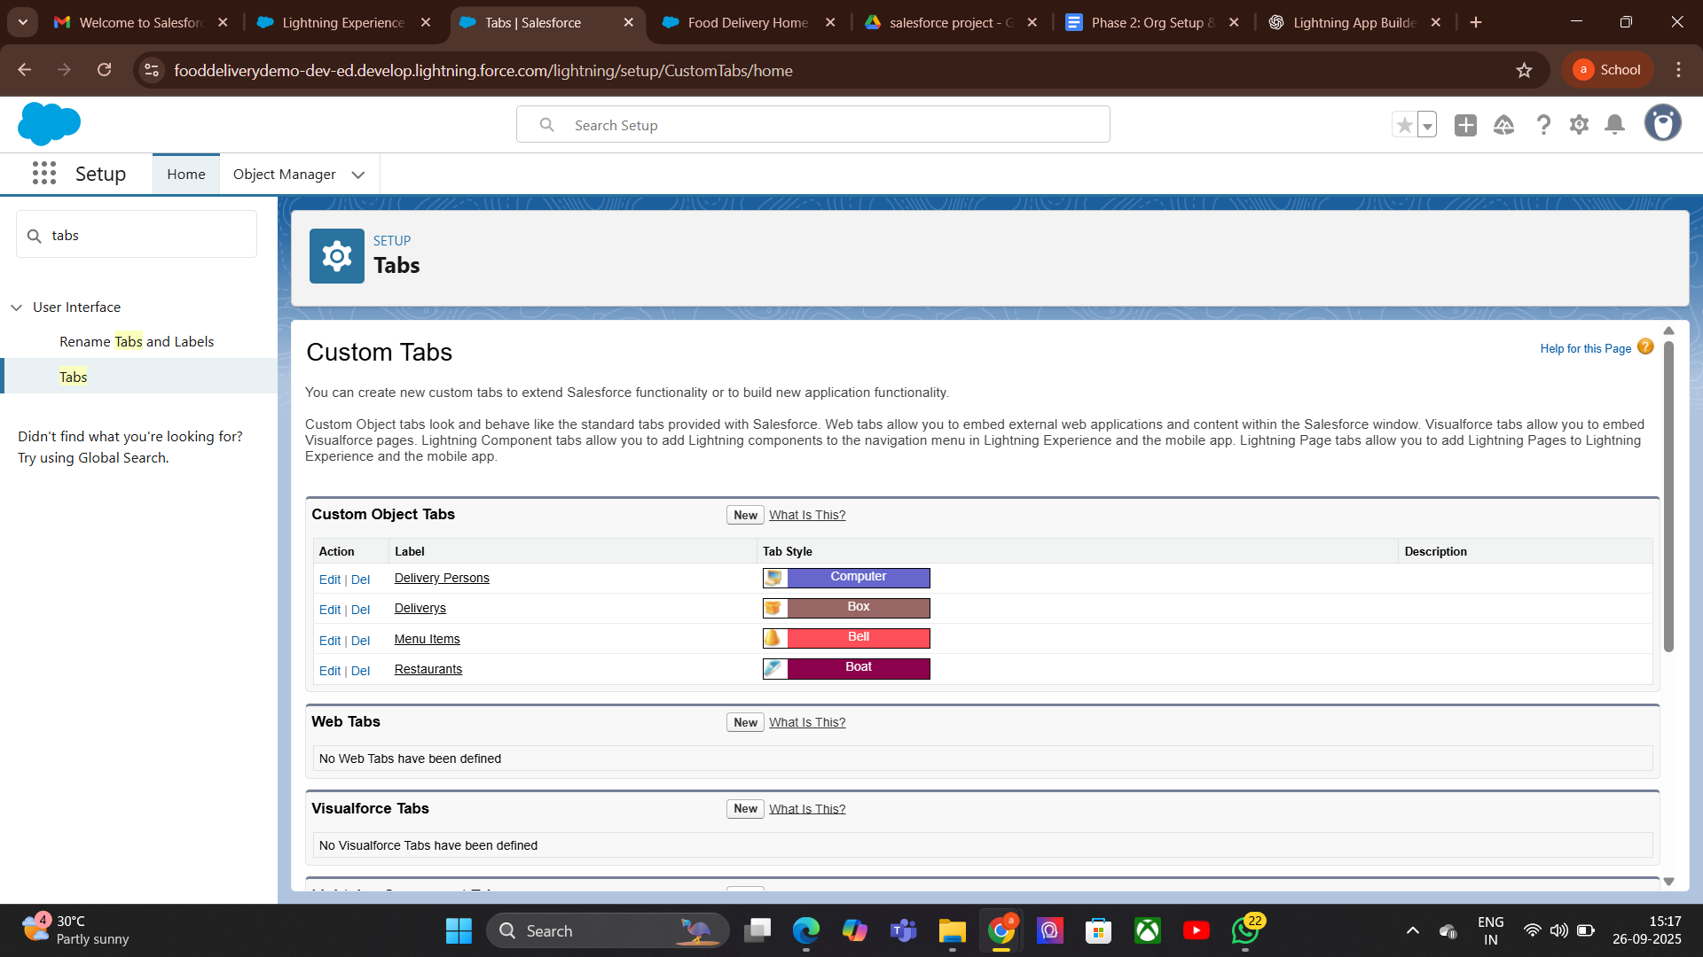

**4. Home Page Layouts:**

* Definition: Custom layouts for the Salesforce Home Page that organize components and data for users.
* Purpose: Provide quick access to important information, reports, and tools.
* Examples: Dashboards, recent records, tasks, notifications.
* Usage: Customize for roles, profiles, or apps to improve productivity.
* **Go to Setup** → Search **"Home Page Layouts"**.
* **Click "New"** to create a new layout.
* **Enter Layout Name** and description.
* **Select Components** to add (e.g., dashboards, reports, tasks, news, recent records).
* **Arrange Components** in desired order.
* **Save Layout**.

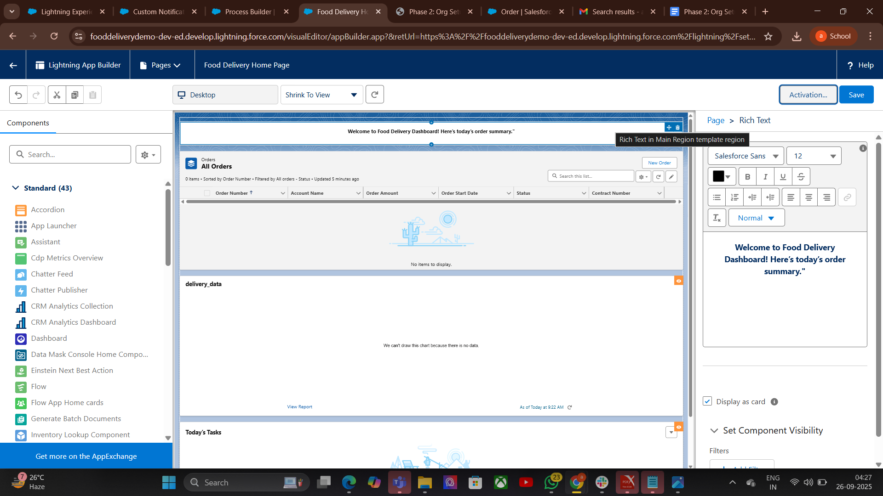

**5.Utility Bar:**

The Utility Bar is a customizable toolbar in Lightning Experience that appears at the bottom of the app. It gives users quick access to frequently used tools without leaving their current page.

* Go to Setup → App Manager.
* Select the Lightning App → Click Edit.
* Go to Utility Bar.
* Click Add Utility and choose the component/tool.
* Configure label, icon, and behavior.
* Save and activate.

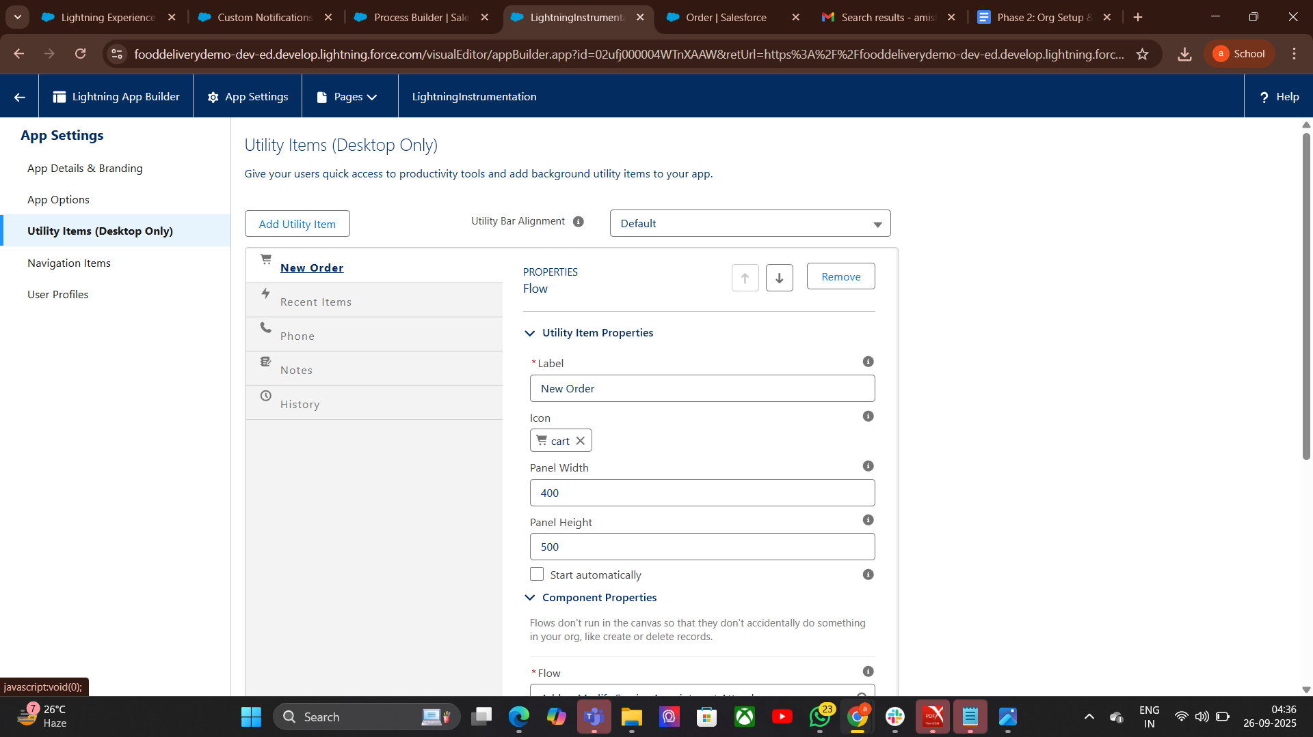

**7. LWC (Lightning Web Components):(**not implemented**)**

LWC is Salesforce’s modern JavaScript-based framework that uses web standards (HTML, CSS, JavaScript).

It provides a lightweight, high-performance way to build reusable UI components.

**8.Apex with LWC:**

* Definition: Apex is the server-side language in Salesforce that processes business logic and database operations, while LWC (Lightning Web Component) is the client-side UI framework. Together, they create a dynamic and responsive Food Delivery app.
* Purpose in Food Delivery:
  + LWC displays menus, orders, and delivery status to users.
  + Apex fetches menu data, creates orders, updates delivery status, and manages backend logic.
* How it works:
  + LWC calls Apex methods using @wire or imperative calls.
  + Apex processes the request, interacts with Salesforce database, and returns data.
  + LWC updates the UI based on Apex response.
* Example Use:
  + Show restaurant menu.
  + Place new order.
  + Track delivery status.

**9.Events in LWC:**

Definition: Events in Lightning Web Components (LWC) are custom or standard signals used to communicate between components or to trigger actions.

Purpose: To allow components to communicate in a structured way without tight coupling.

### Types of Events in LWC

1. Standard DOM Events
   * Built-in events like click, change, input.
   * Example: <button onclick={handleClick}>Click Me</button>.
2. Custom Events
   * Used to send data between components.
   * Created using CustomEvent in JavaScript.
   * Can carry data in the detail property.

**10. Imperative Apex Calls:**

Definition: Imperative Apex calls in LWC are manual calls to Apex methods (not automatic like @wire) made when certain actions occur, such as button clicks.

Purpose: Gives more control over when Apex methods run and allows passing dynamic parameters.

public with sharing class FoodDeliveryController {

@AuraEnabled

public static List<Menu_Item__c> getMenuItems(Id restaurantId) {

return [

SELECT Id, Name, Price__c

FROM Menu_Item__c

WHERE Restaurant__c = :restaurantId

];

}

}

### **Key Points:**

* Must import Apex method in LWC JavaScript.
* Apex method must be @AuraEnabled.
* Called inside a JavaScript function, usually in response to user actions.
* Returns a Promise, so .then() and .catch() are used for handling results and errors.

**7.Integration & External Access:**

**1.Named Credentials**

Purpose: Securely store API URLs and login details, simplify integrations.

**Security** → Credentials are stored securely by Salesforce, not visible in plain text.

Easy Callouts → Developers can call APIs using a simple reference (callout:Name).

Authentication Types → Supports Password, OAuth 2.0, JWT, AWS Signature, etc.

Identity Types →  
Named Principal → One login for all users.  
Per User → Each user has their own login.

Usage in Apex/Flow → Can be used directly in Apex callouts, Flows, and External Services.  
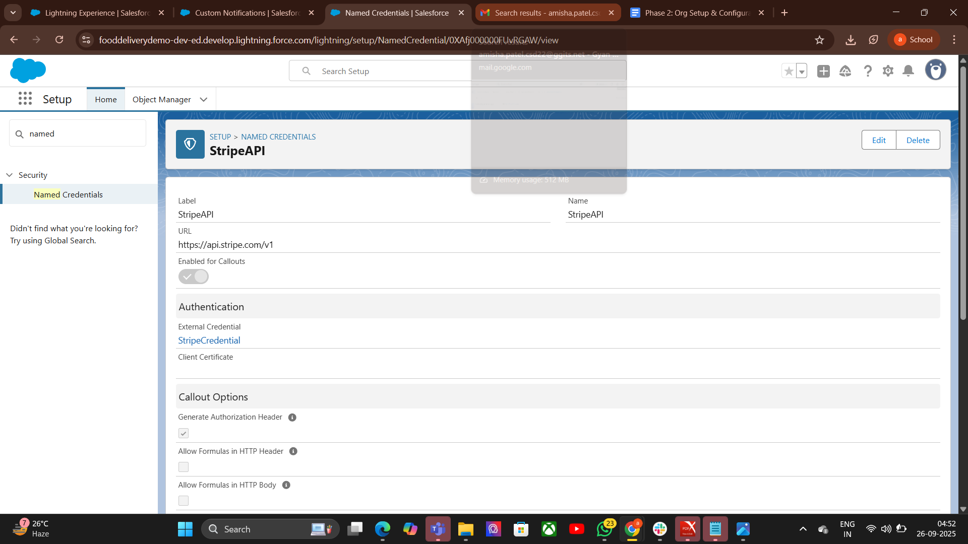

**2.External Services**

### **Purpose**

Connect Salesforce with **external REST APIs** easily.  
Allow **admins (non-developers)** to use external APIs in **Flow or Process Builder**.

**Pepare API Schema** → Get an **OpenAPI (Swagger) definition** of the external REST API.

**Set Up Named Credential** → Store API base URL + authentication securely.

**Register External Service** →

* Go to Setup → **External Services** → New.
* Upload/OpenAPI schema.
* Link it with the **Named Credential**.

**Generate Actions** → Salesforce auto-creates invocable actions from the schema

**Use in Flow/Apex** →

* In Flow, drag **Action** → search API action → use it like a standard Salesforce action.
* In Apex, invoke via Named Credential callout if needed.  
  **Test Integration** → Run Flow/Process to confirm external API is working

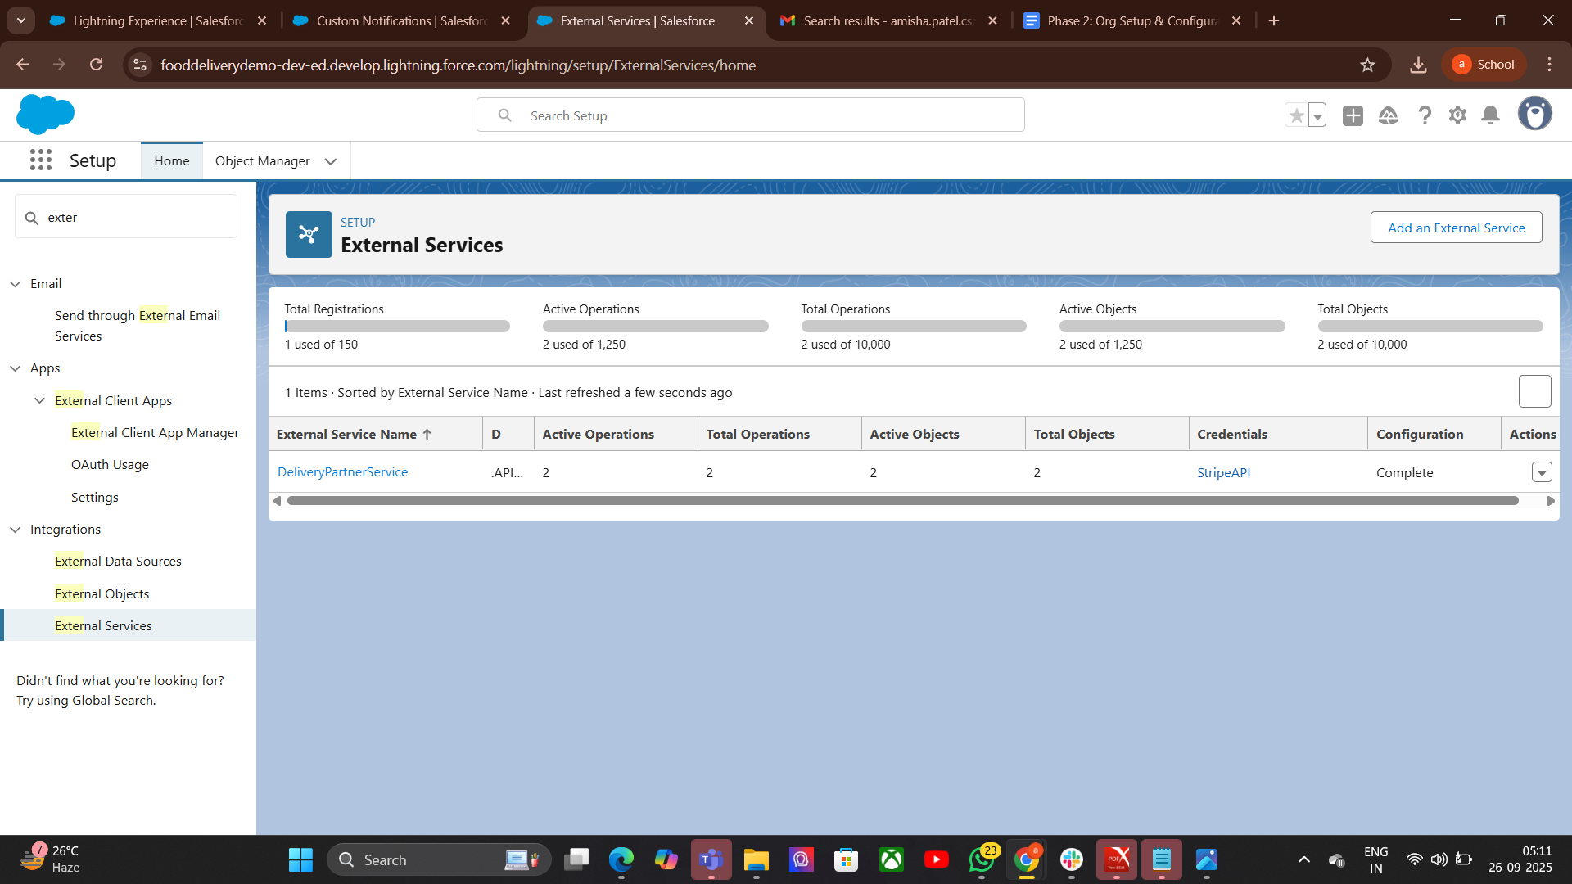

**3.• Callouts**

### **Purpose**

* Allow Salesforce to send requests to external systems (APIs/web services).
* Fetch or send real-time data (e.g., payment status, shipping updates).
* Enable integration between Salesforce and third-party applications.

## Callouts – Process

## Whitelist Endpoint → Add API URL in Remote Site Settings or use Named Credentials. Create HTTP Request → Define endpoint, method (GET/POST), headers, body.

## Send Callout → Use Http class in Apex (or Flow with External Services). Get Response → Parse JSON/XML result. Update Salesforce Data → Save response in records/fields.

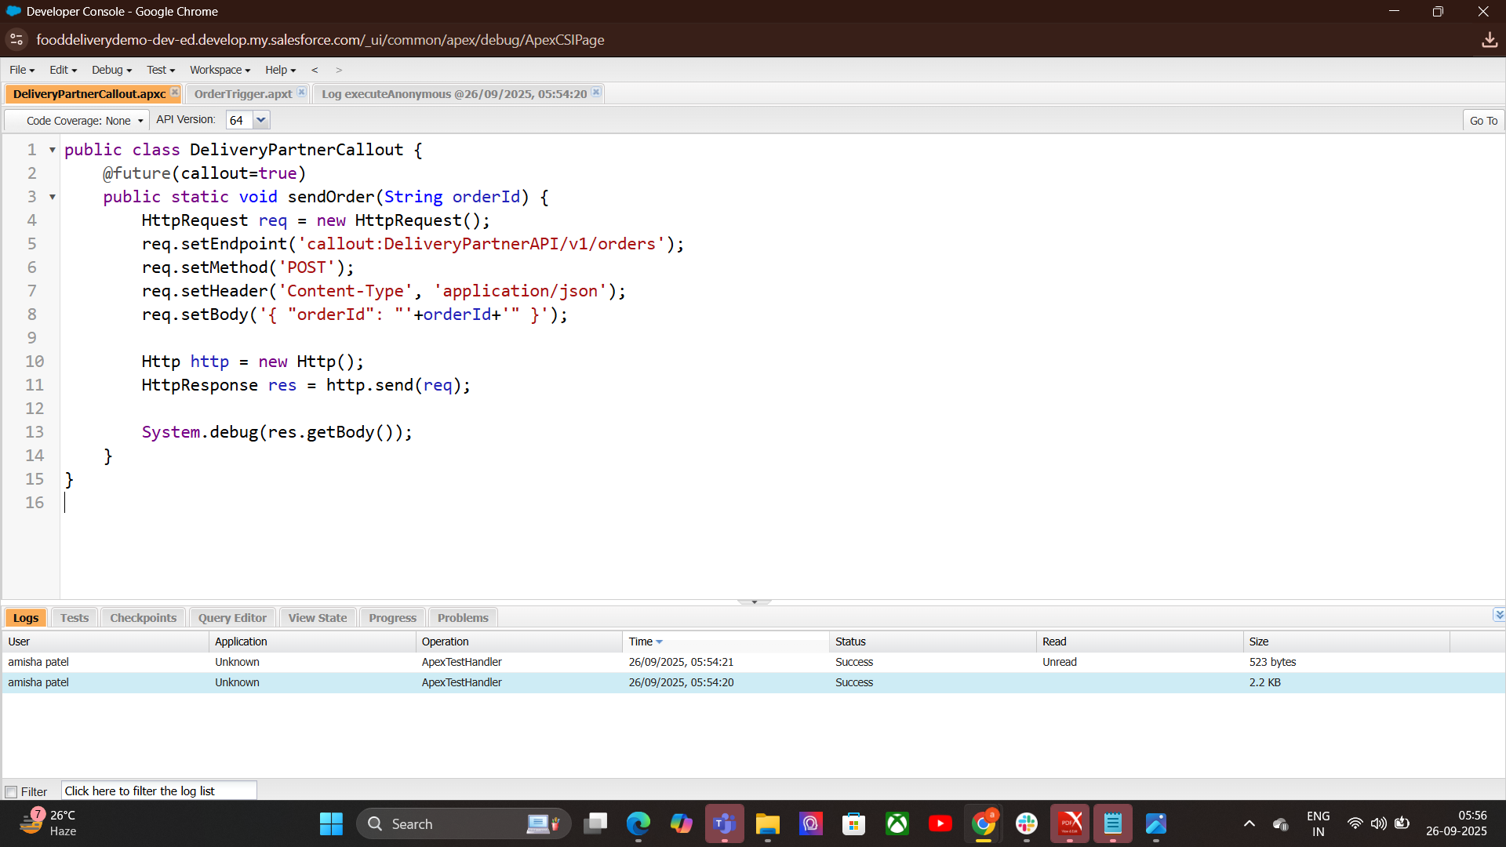

**4.Platform Events:**

### Purpose

* Enable real-time communication between Salesforce and external systems.
* Work on publish–subscribe model (like messaging queues)

Process-Create Platform Event → In Setup, define fields (like OrderId, Status).

Publish Event → From Apex, Flow, or API when something happens.  
Subscribe to Event →

* Inside Salesforce (Triggers, Flows).
* Outside Salesforce (via CometD API, Middleware).
* React in Real-Time → Update records, notify users, or call external apps.



**5. Change Data Capture:**

### Purpose

* Automatically broadcast changes in Salesforce records (Insert, Update, Delete, Undelete).
* Keep external systems in sync without polling.

### Process

1. Enable CDC → Go to Setup → Change Data Capture → Select Objects.
2. Publish Events Automatically → Salesforce generates events when records change
3. Subscribe to Events → External system subscribes via CometD API or Salesforce Streaming API.
4. Process Changes → Update external system or take actions in Salesforce.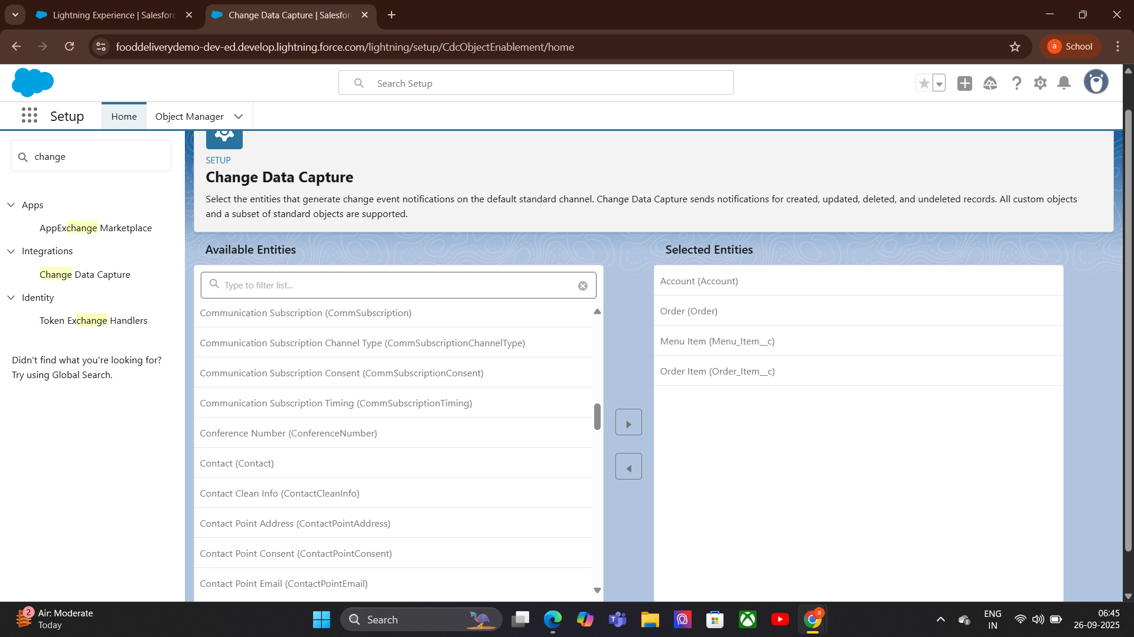

**6.Platform Events:**

**Purpose**

* Enable real-time communication between Salesforce and other systems.
* Automate processes using event-driven architecture.
* Keep systems loosely coupled and scalable.

### **Process**

1. Create Platform Event → Define event fields in Setup.
2. Publish Event → From Apex, Flow, Process Builder, or API.
3. Subscribe to Event →
   * Apex Trigger (internal).
   * Flow.
   * External system via CometD API.
4. Process Event Data → Update records, trigger workflows, or call APIs

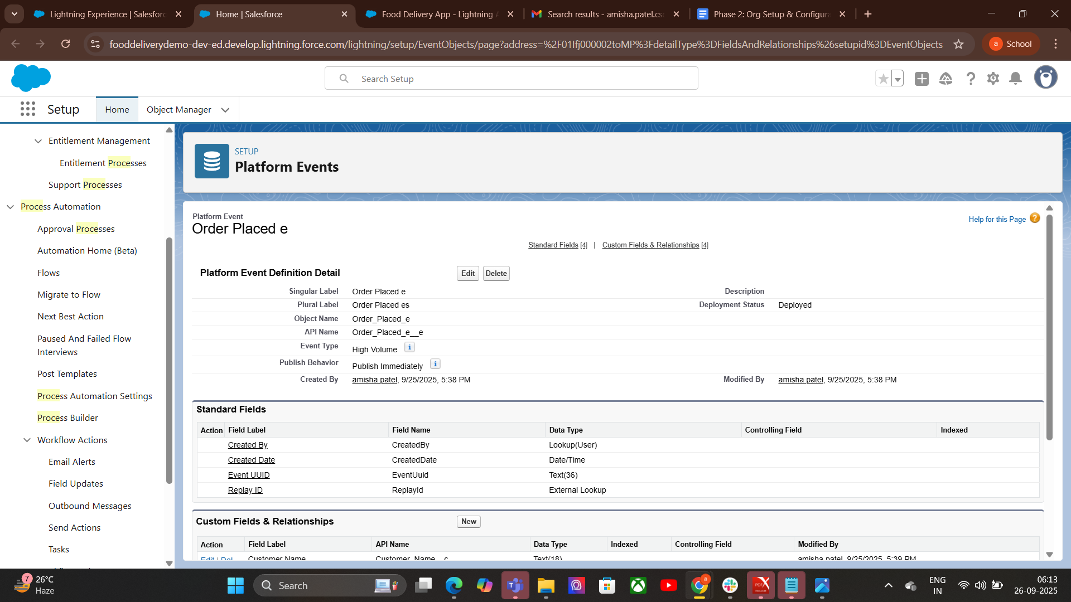

**7.API Limits:**

### Purpose

* Protect Salesforce performance and stability.
* Prevent excessive API usage that could overload the system.
* Ensure fair usage across users and integrations.

### Steps (Process)

1. Understand Your Limit → Check API usage in Setup → System Overview or API Usage.
2. Track API Calls → Every REST, SOAP, Bulk API, and streaming event counts.
3. Optimize Calls → Combine requests, use Bulk API, or cache results to reduce calls.
4. Monitor Usage → Use reports or API Usage dashboards to avoid hitting limits.
5. Plan for Scaling → Upgrade edition or request extra API calls if needed.

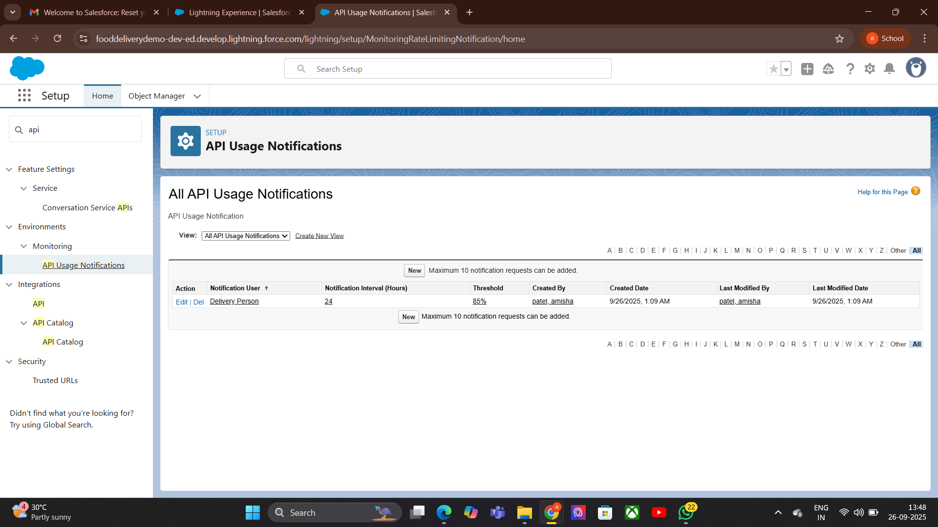

**8.OAuth & Authentication:**

### Purpose

* Securely connect external applications with Salesforce without sharing passwords.
* Control access using tokens instead of credentials.
* Support multiple authentication flows for different scenarios.

### **Steps (Process)**

1. Choose Authentication Flow → e.g., Web Server Flow, JWT, Username-Password Flow.
2. Create Connected App → In Salesforce Setup → specify app details, callback URL, scopes.
3. Get Client Credentials → Client ID and Client Secret from Connected App.
4. Request Access Token → External app authenticates and receives token from Salesforce.
5. Use Token in API Calls → Send token in HTTP headers for authentication.
6. Refresh Token When Needed → Tokens expire, refresh without re-login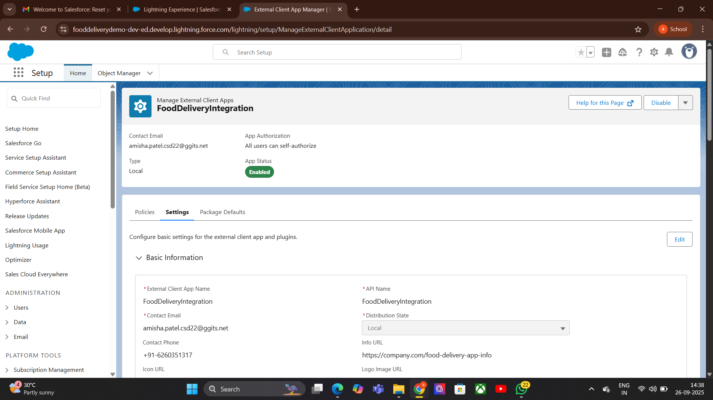

**9.Remote Site Settings:**

### Purpose

* Whitelist external URLs so Salesforce can make HTTP callouts to them.
* Protect Salesforce from unauthorized external requests.
* Ensure security by restricting callouts to known endpoints

### **Steps (Process)**

1. Go to Setup → Search Remote Site Settings.
2. Click “New Remote Site”.
3. Enter Details →
   * Remote Site Name → descriptive name (e.g., FoodAPI).
   * Remote Site URL → API base URL (e.g., https://api.fooddelivery.com).
4. Save → Salesforce now allows callouts to this URL.
5. Use in Callouts → Apex/Flow callouts can now connect to the whitelisted endpoint.

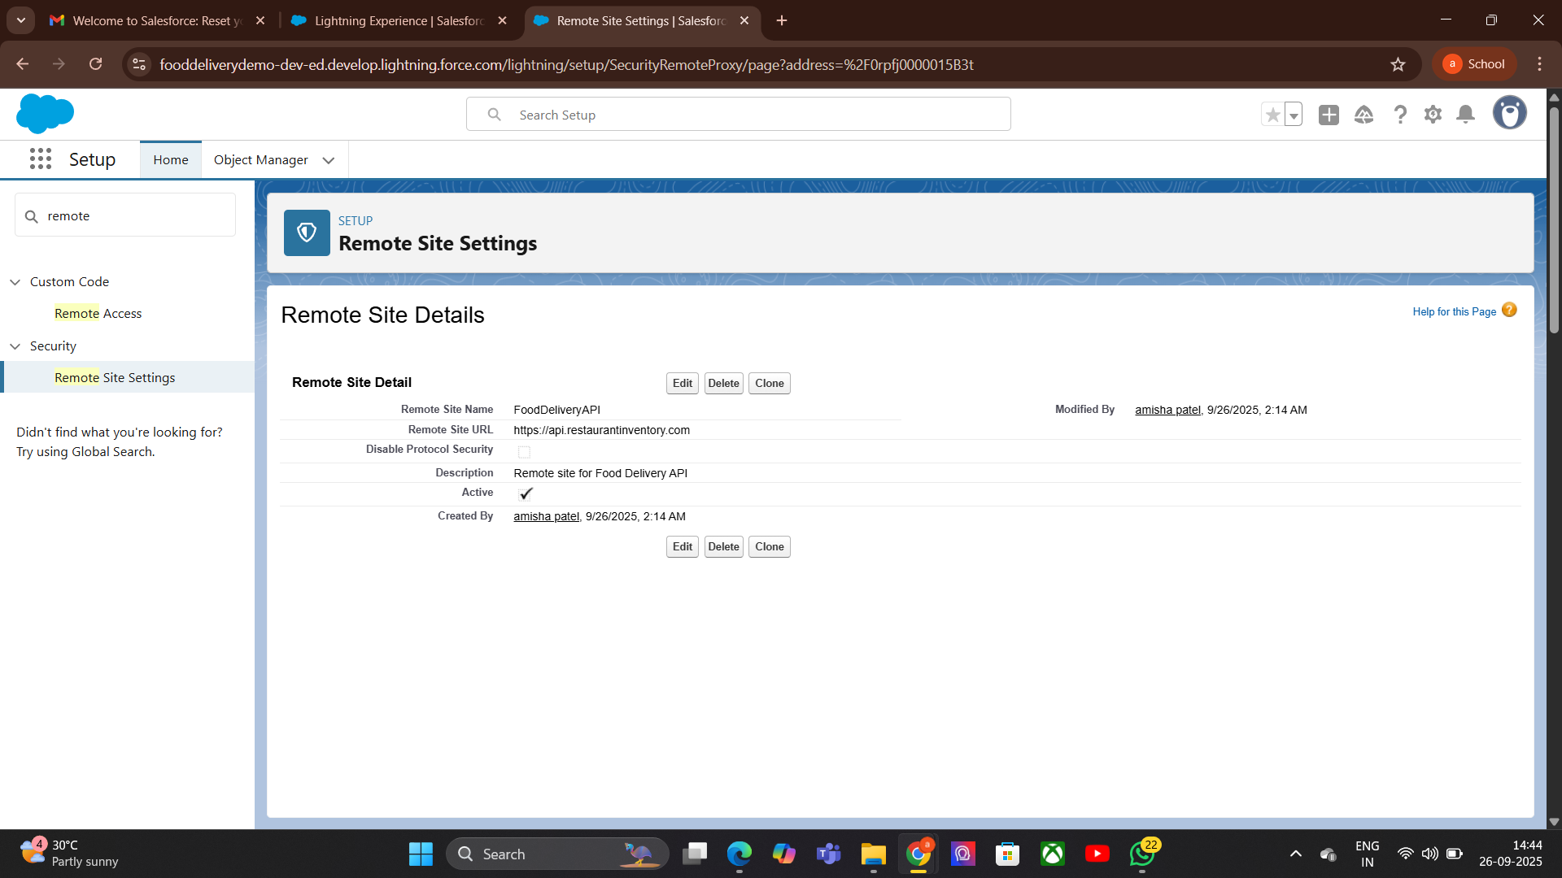

# **Phase 8: Data Management & Deployment:**

**1. Data Import Wizard:**

### Purpose

* Simplify data import into Salesforce without coding.
* Import data for standard and custom objects

.Steps (Process)

1. Go to Setup → Search Data Import Wizard.
2. Select Object → Choose standard/custom object (e.g., Contacts, Orders).
3. Choose Data File → Upload CSV file with data.
4. Map Fields → Match CSV columns to Salesforce fields.
5. Start Import → Salesforce processes the file and imports data.
6. Review Import Results → Check success/errors.

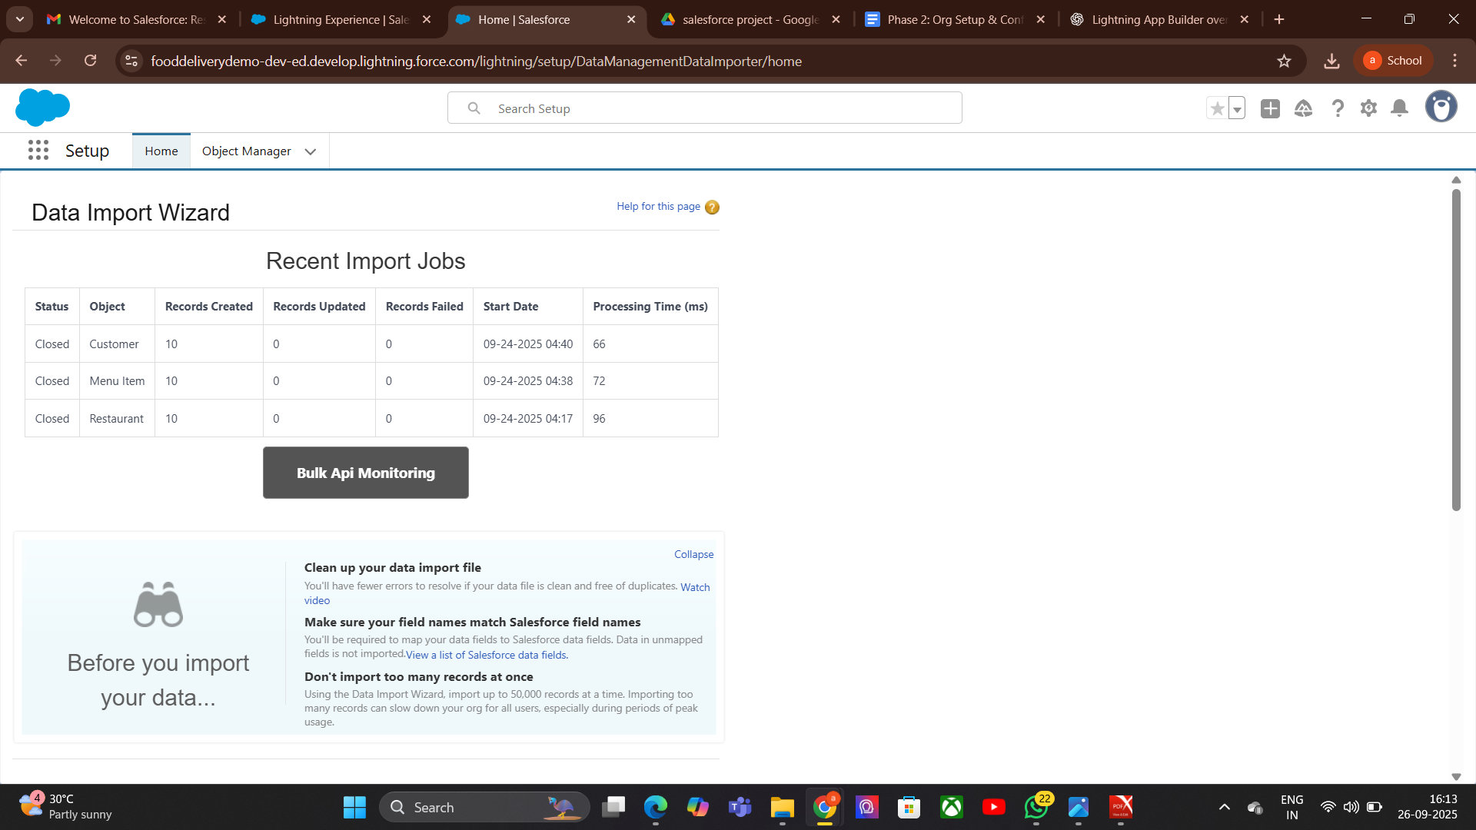

**2. Duplicate Rules:**

### Purpose

* Prevent creation of duplicate records in Salesforce.
* Improve data quality and maintain clean records.
* Alert users or block duplicates during record creation or import.

### Steps (Process)

1. Go to Setup → Search Duplicate Rules.
2. Create New Rule → Select object (e.g., Contacts, Leads, Accounts).
3. Select Matching Rule → Choose an existing rule or create a new one to define matching criteria.
4. Set Rule Action →
   * Alert → Notify user but allow save.
   * Block → Prevent duplicate record creation.
5. Activate Rule → Turn it ON to enforce duplicates checking.
6. Test Rule → Try creating duplicate record and verify behavior.

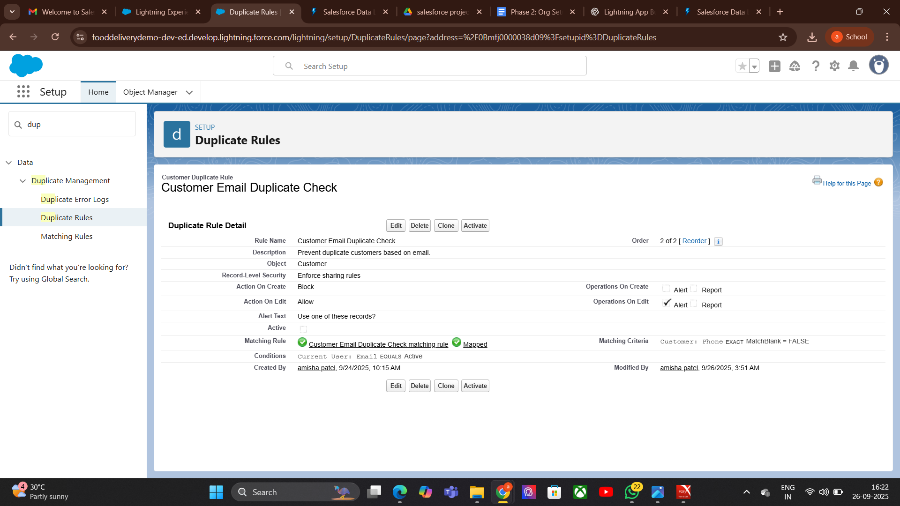

**3.Data Export :**

### Purpose

* Extract Salesforce data for backup, migration, or reporting.
* Export data for both standard and custom objects.
* Schedule regular exports to maintain backups.

### **Steps (Process)**

1. Go to Setup → Search Data Export.
2. Choose Export Type →
   * Manual Export → Run export instantly.
   * Scheduled Export → Set a schedule (weekly/monthly).
3. Select Objects → Choose specific objects or all data.
4. Select Export Options → Include attachments, documents, chatter files if needed.
5. Start Export → Salesforce prepares ZIP files with CSV data.
6. Download Files → Use provided link once export is complete.

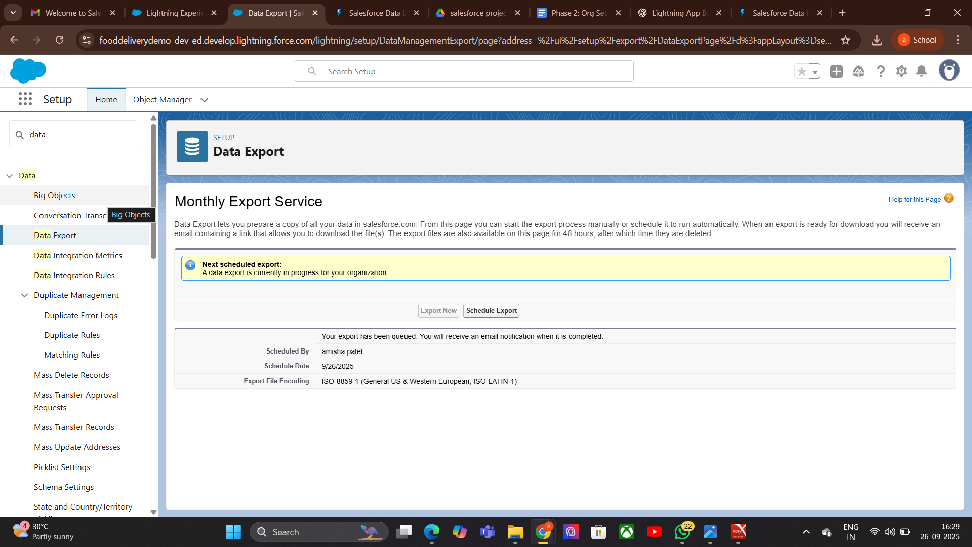

**4. Unmanaged vs Managed Packages**:

unmanaged-

Purpose-Used for sharing code/configuration for learning or one-time installation.

No upgrade support — changes must be manually applied.

#### **Unmanaged Package**

* Go to Setup → Search Packages.
* Click New → Name package.
* Add components (objects, fields, Apex classes, etc.).
* Upload → Generate install link.
* Install in target org.

**Managed**-

Used for distributing apps in AppExchange or for controlled upgrades.

Supports upgrades and version control

**process-**

Go to Setup → Create a **Developer Edition org**.

Create package and add components.

Register namespace (unique).

Upload package as managed.

Install via AppExchange link.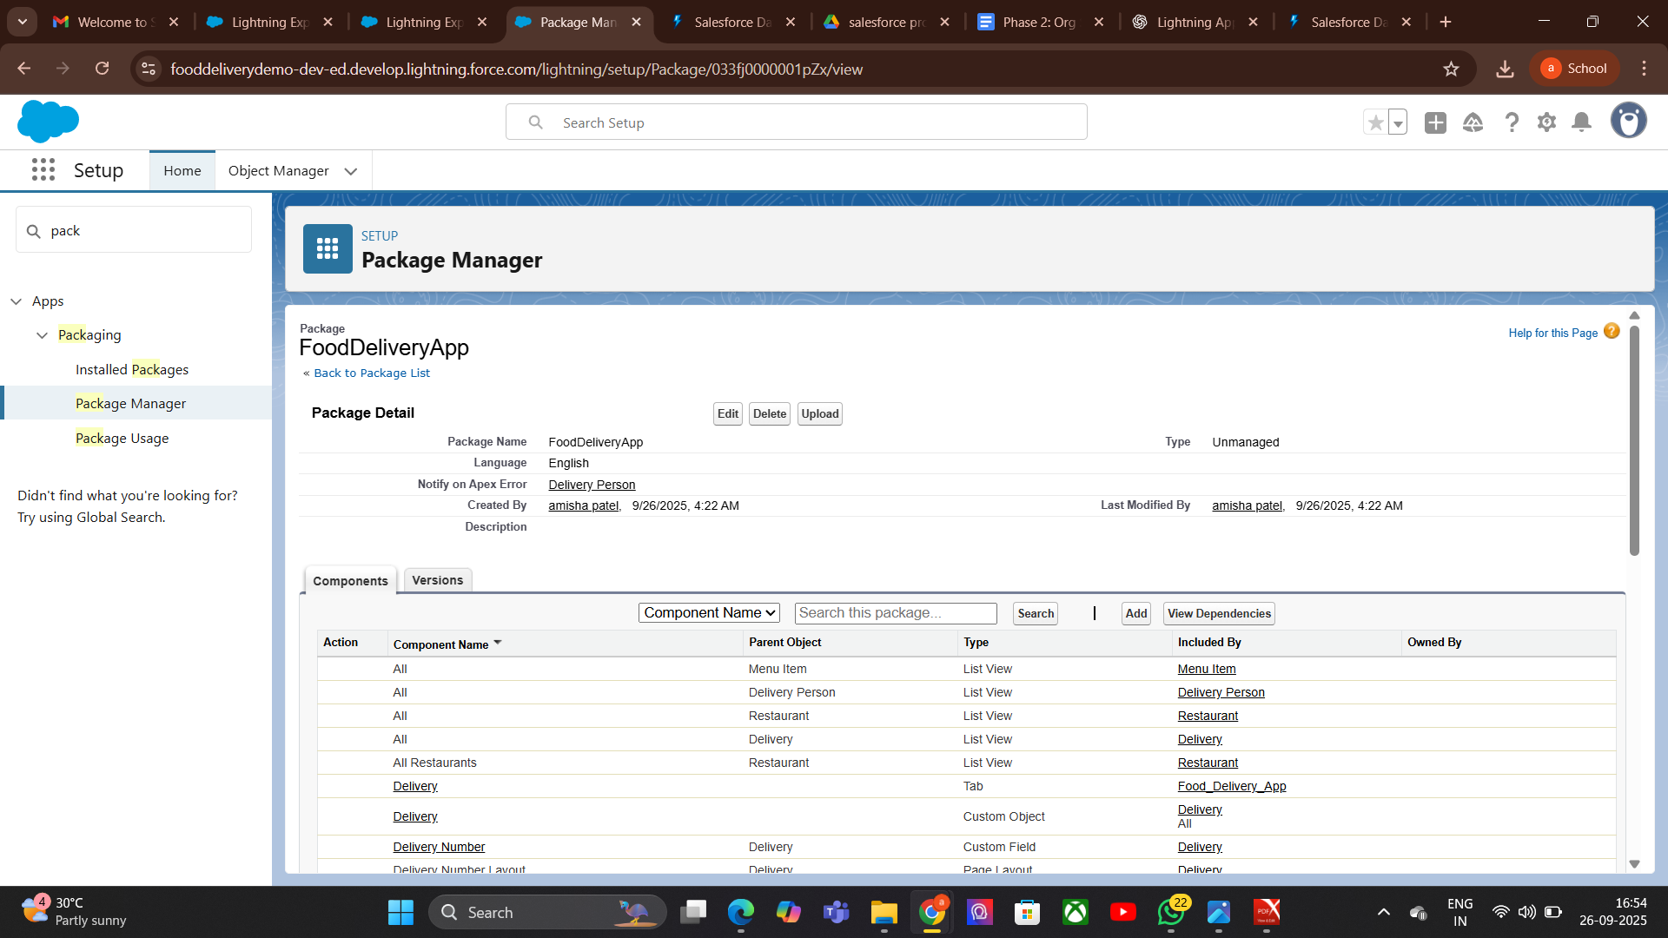

**5.ANT Migration Tool:**

### **Purpose**

* Automate deployment of metadata between Salesforce orgs.
* Useful for continuous integration (CI) and version control.
* Works well for large projects with many components.

### **Steps (Process)**

1. **Install Java & ANT** → Ensure Java and Apache ANT are installed on your system.
2. **Download Salesforce ANT Migration Tool** → From Salesforce Setup → Tools → Force.com Migration Tool.
3. **Set Up project folder** → Create a folder for project and build files.
4. **Configure build.xml & package.xml** → Define metadata to retrieve/deploy.
5. **Retrieve Metadata** → Use ANT command:
6. ant retrieve
7. **Deploy Metadata** → Use ANT command:
8. ant deploy
9. **Check Deployment Results** → Review logs

**6.Data Loader:**

**Purpose**

* Bulk import, export, update, delete Salesforce records.
* Useful for large data operations (thousands or millions of records).
* Supports CSV file format and automation via command line.

### **Steps (Process)**

* Download & Install Data Loader → From Salesforce Setup → Data Loader.
* Login → Use Salesforce credentials (or OAuth).
* Select Operation → Insert, Update, Upsert, Delete, Export, Export All.
* Choose Object → Select the Salesforce object to work on (e.g., Contact, Account).
* Select CSV File → Map CSV columns to Salesforce fields.
* Run Operation → Process the data.
* Check Results → Review success and error files generated by Data Loader.

**7.VS Code & SFDX:**

### **Purpose**

* VS Code → Powerful code editor for Salesforce development.
* SFDX (Salesforce DX) → CLI tool for modern Salesforce development and deployment.
* Enable source-driven development, version control, and team collaboration

### **Small Steps (Process)**

1. **Install VS Code** → Download from Visual Studio Code website.
2. **Install Salesforce Extensions Pack** → From VS Code Extensions Marketplace.
3. **Install Salesforce CLI (SFDX)** → From Salesforce Developer site.

**Authorize Org** →  
 sfdx force:auth:web:login -a MyOrgAlias

**Create Project** →  
 sfdx force:project:create -n MyProject

**Retrieve Metadata** →  
 sfdx force:source:retrieve -m ApexClass:MyClass

**Deploy Metadata** →  
 sfdx force:source:deploy -p force-app

**Run Tests** →  
 sfdx force:apex:test:run

**Phase 9: Reporting, Dashboards & Security Review**

**1. Report Types:**

### Purpose

* Define which objects and fields are available for reports in Salesforce.
* Control how records are related in reports.
* Allow creation of custom reports for specific business needs.

### **Small Steps (Process)**

* **Go to Setup** → Search **Report Types**.
* **Click “New Custom Report Type”**.
* **Select Primary Object** → Choose the main object (e.g., Accounts, Orders).
* **Define Related Objects** → Add related objects if needed.
* **Set Deployment Status** → In Development (editable) or Deployed (available to all users).
* **Save** → Use this report type when creating reports.

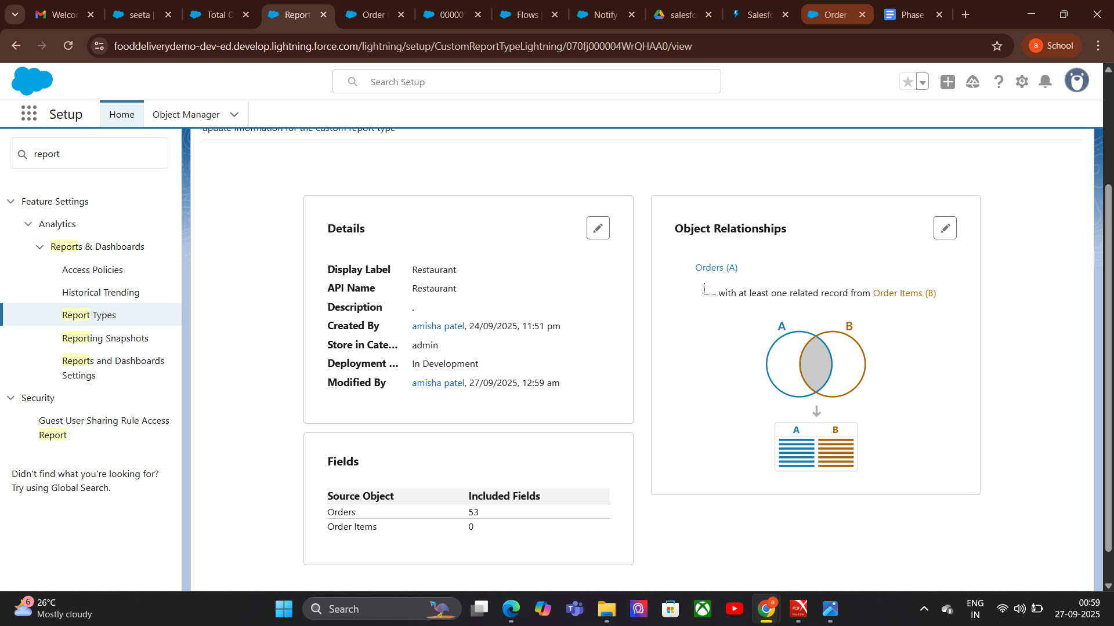

**2. Dashboards:**

### **Purpose**

* Visually display Salesforce data in charts, graphs, tables, and gauges.
* Provide quick insights and analytics for decision-making.
* Summarize reports for managers and teams.

### Steps (Process)

1. Go to Dashboards Tab → Click New Dashboard.
2. Name Dashboard → Give a meaningful name and select a folder.
3. Add Components → Charts, graphs, tables, gauges.
4. Select Source Reports → Choose reports that will feed data to dashboard components.
5. Customize Components → Adjust chart types, filters, labels.
6. Save & Refresh → Ensure data is up-to-date.

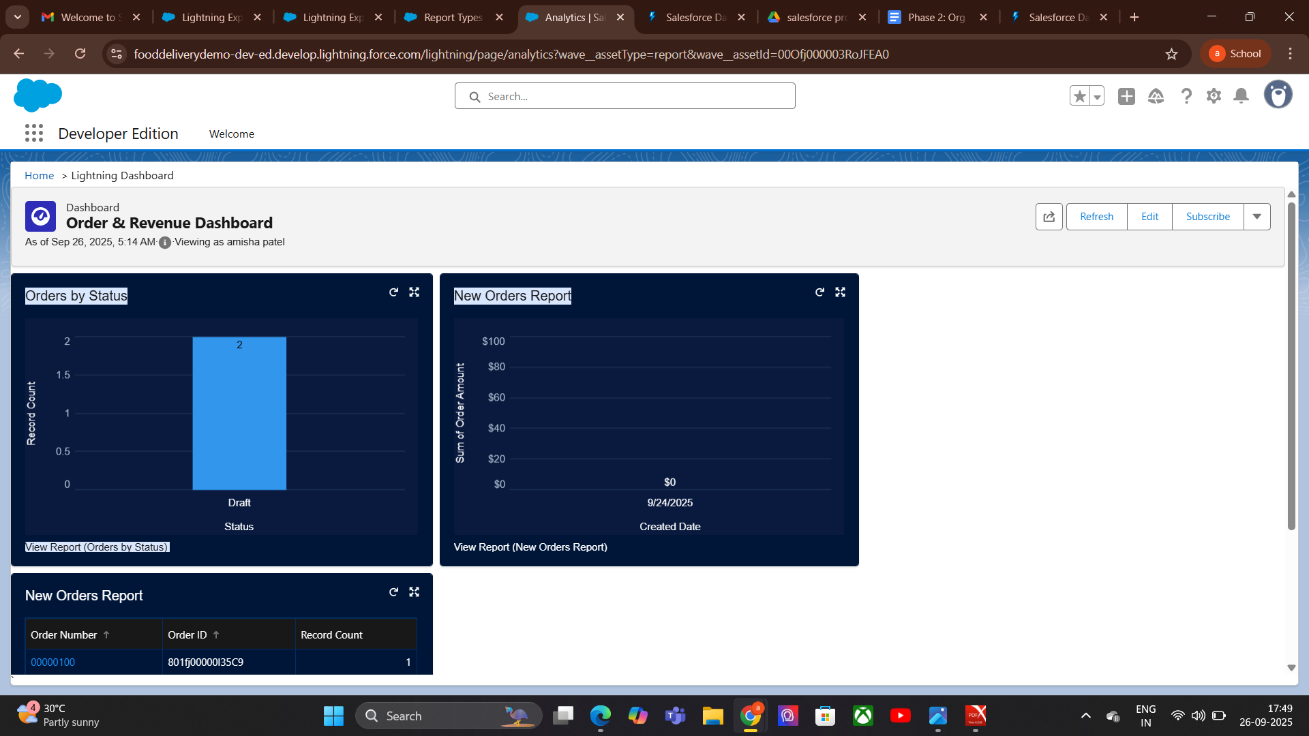

**3.Sharing Settings:**

### **Purpose**

* Control record-level access in Salesforce.
* Define who can view, edit, or delete records.
* Maintain data security while enabling collaboration.

### **Steps (Process)**

1. **Go to Setup** → Search **Sharing Settings**.
2. **Set Organization-Wide Defaults (OWD)** → Define baseline access for each object (Public, Private, Controlled).
3. **Create Sharing Rules** → Grant access to specific groups/roles.
4. **Use Role Hierarchies** → Inherit access based on role levels.
5. **Set Manual Sharing** → Allow record owners to share records individually.
6. **Test Access** → Log in as a user to verify permissions.

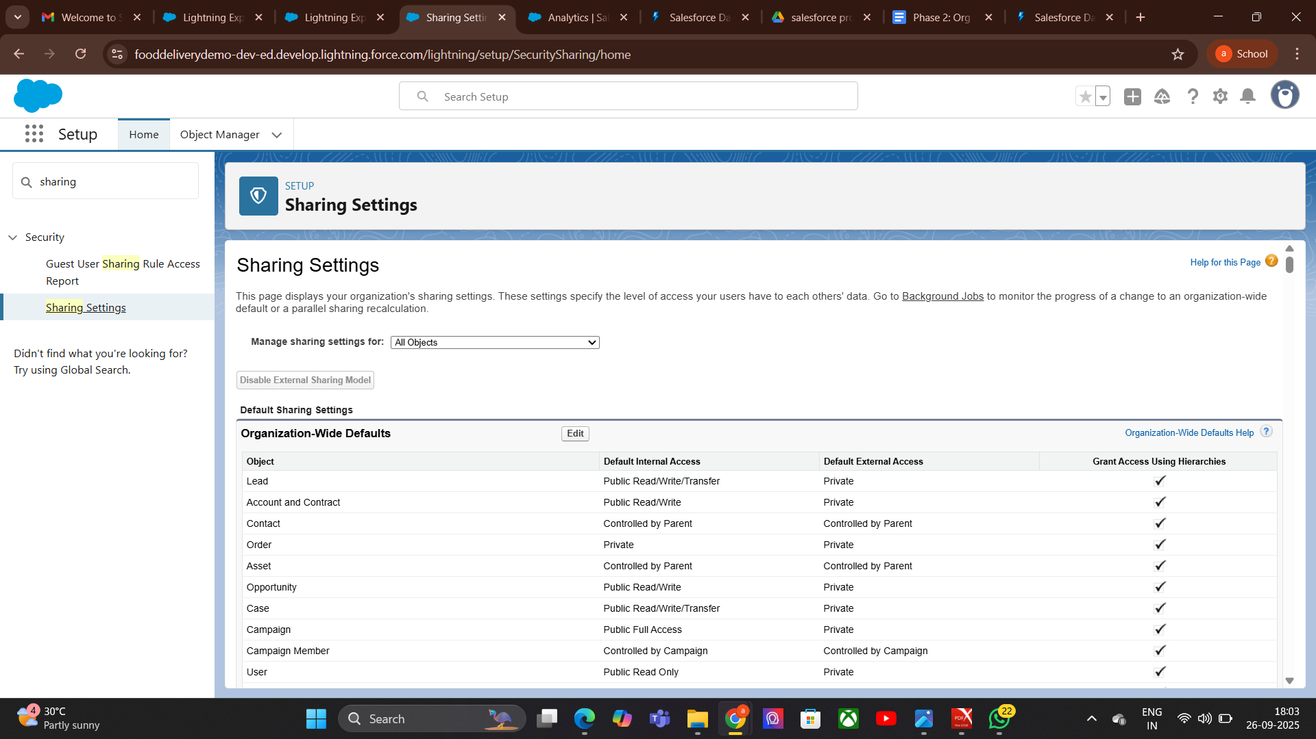

**4.Field Level Security:**

### Purpose

* Control visibility and editability of individual fields in Salesforce objects.
* Protect sensitive data while allowing access to necessary information.
* Apply security at the profile or permission set level.
* Steps (Process)

1. Go to Setup → Search Field Accessibility or Profiles.
2. Select Object → Choose the object containing the field.
3. Select Field → Click on the field to edit security.
4. Set Access Levels →
   * Visible → User can see the field.
   * Read-Only → User can view but not edit.
   * Hidden → Field is not visible.
5. Save Changes → Apply settings for profiles or permission sets.
6. Test Access → Log in as user to confirm field visibility.

**5.Session Settings:**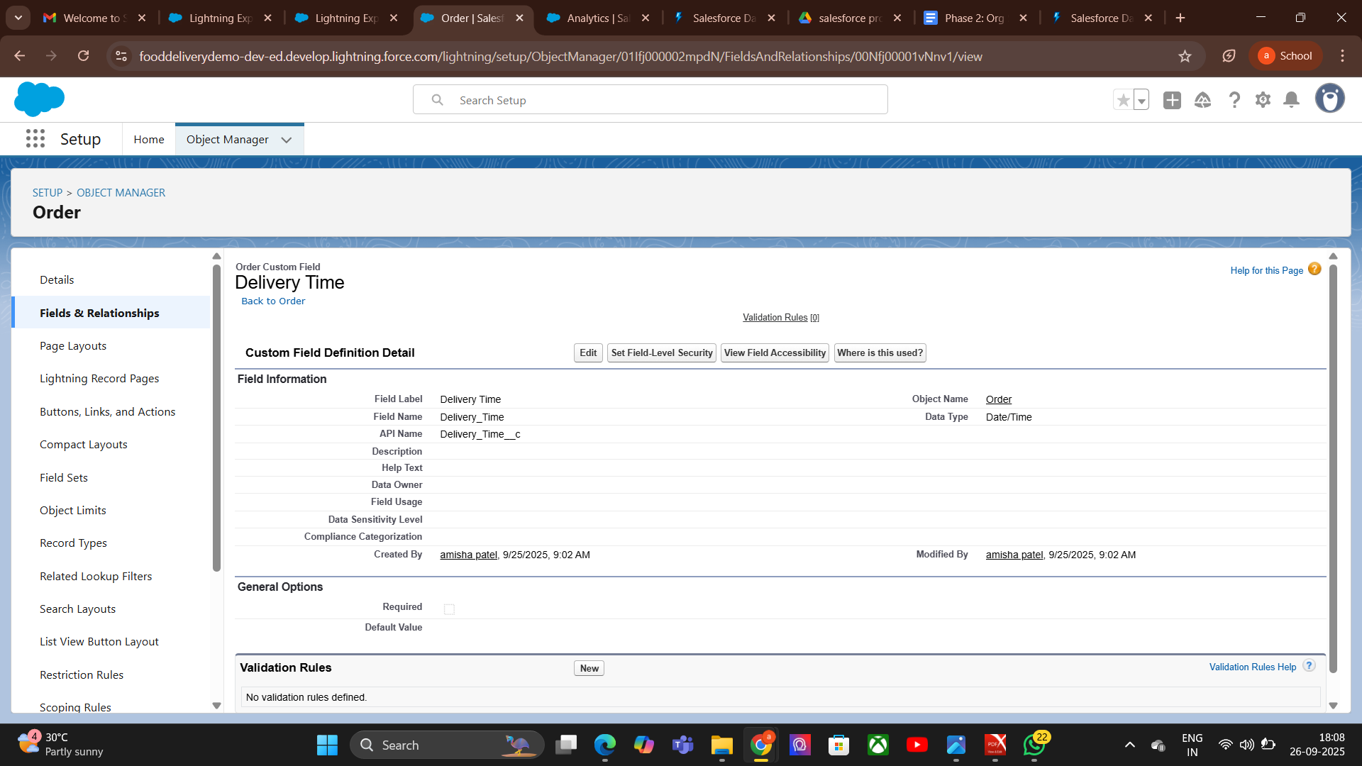

### **Purpose**

* Control user session behavior in Salesforce for security and performance.
* Define session timeout, security policies, and login access.
* Protect org data by managing how and when sessions expire.

### Steps (Process)

### Go to Setup → Search Session Settings.

1. Set Session Timeout → Choose duration (e.g., 30 min, 2 hours).
2. Configure Security Policies → Enable/disable secure session settings (e.g., IPranges, login hours).
3. Enable/Disable Persistent Sessions → Decide whether users stay logged in across browser restarts.
4. Save Changes → Apply settings.
5. Test → Log in as a user to verify session behavior.

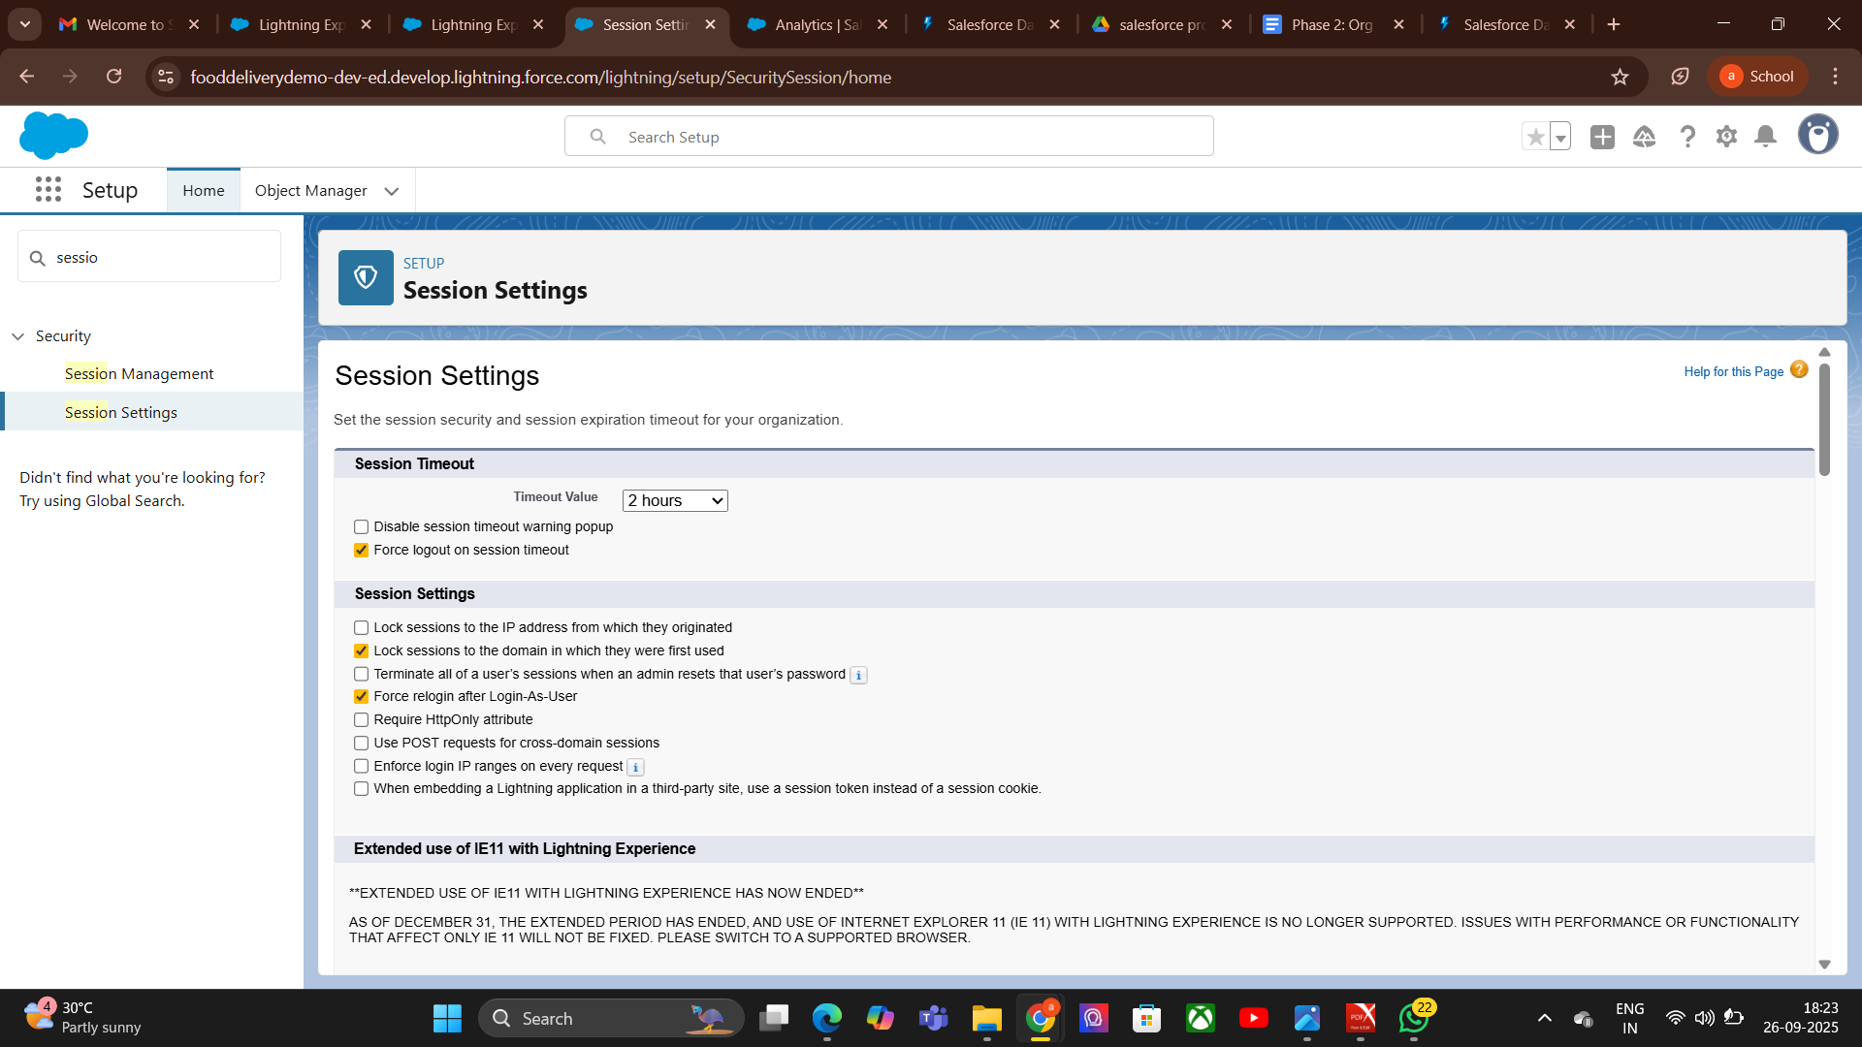

**6.Login IP Ranges:**

### **Purpose**

* Restrict Salesforce login access to specific IP address ranges.
* Enhance org security by controlling where users can log in from.
* Useful for enforcing network-based access control.

### Steps (Process)

1. Go to Setup → Search Profiles (IP ranges are set per profile).
2. Select Profile → Click the profile you want to set IP ranges for.
3. Find Login IP Ranges Section → Click New.
4. Enter IP Range → Start IP and End IP addresses (e.g., 103.45.22.10 to 103.45.22.20).
5. Save Changes → Restriction applies immediately.

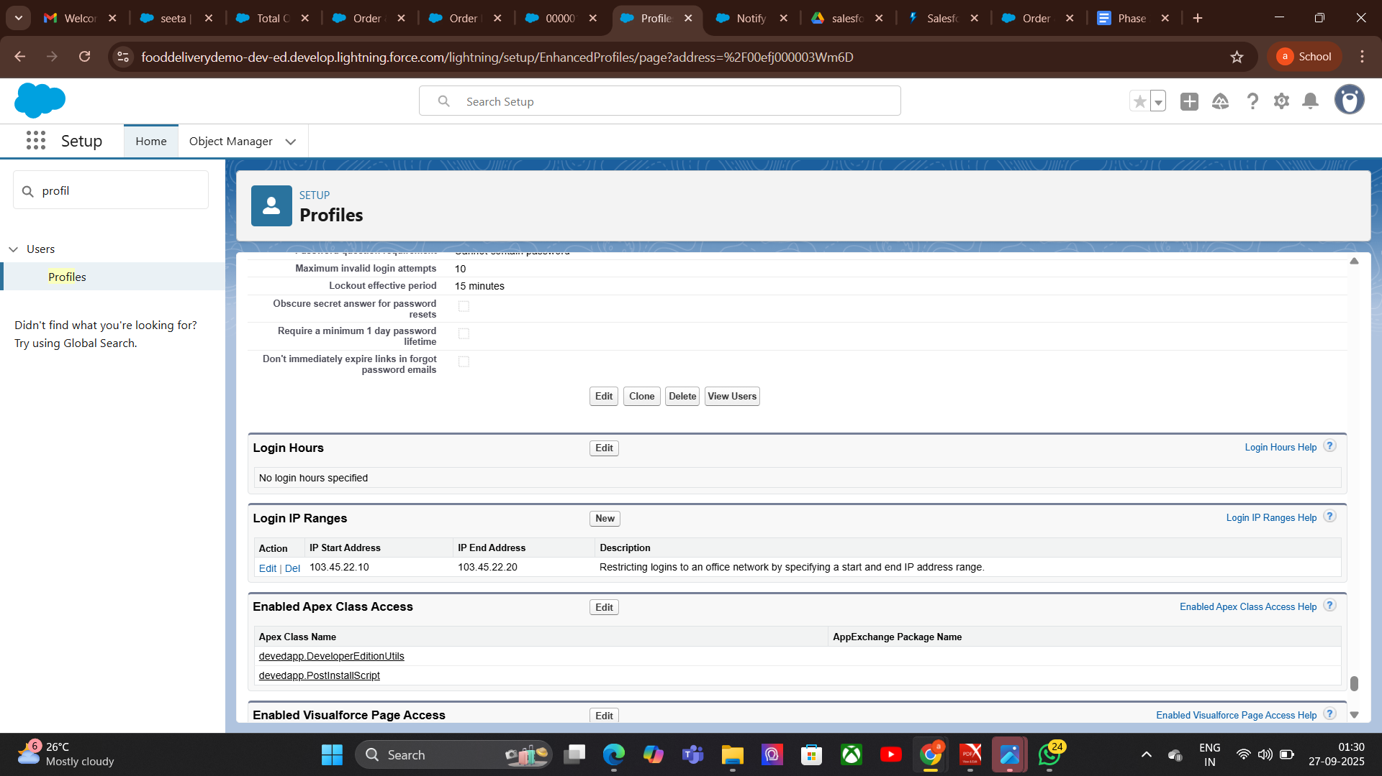

**7.Audit Trail:**

### **Purpose**

* Track administrative changes for accountability.
* Support compliance and security audits.
* Help troubleshoot unexpected behavior by reviewing configuration changes.

### Steps (Process)

1. Go to Setup → Search View Setup Audit Trail.
2. Review Recent Changes → See changes for the last 180 days.
3. Download Audit Log → Export for analysis or compliance documentation.
4. Filter by Date/User → Focus on specific changes.

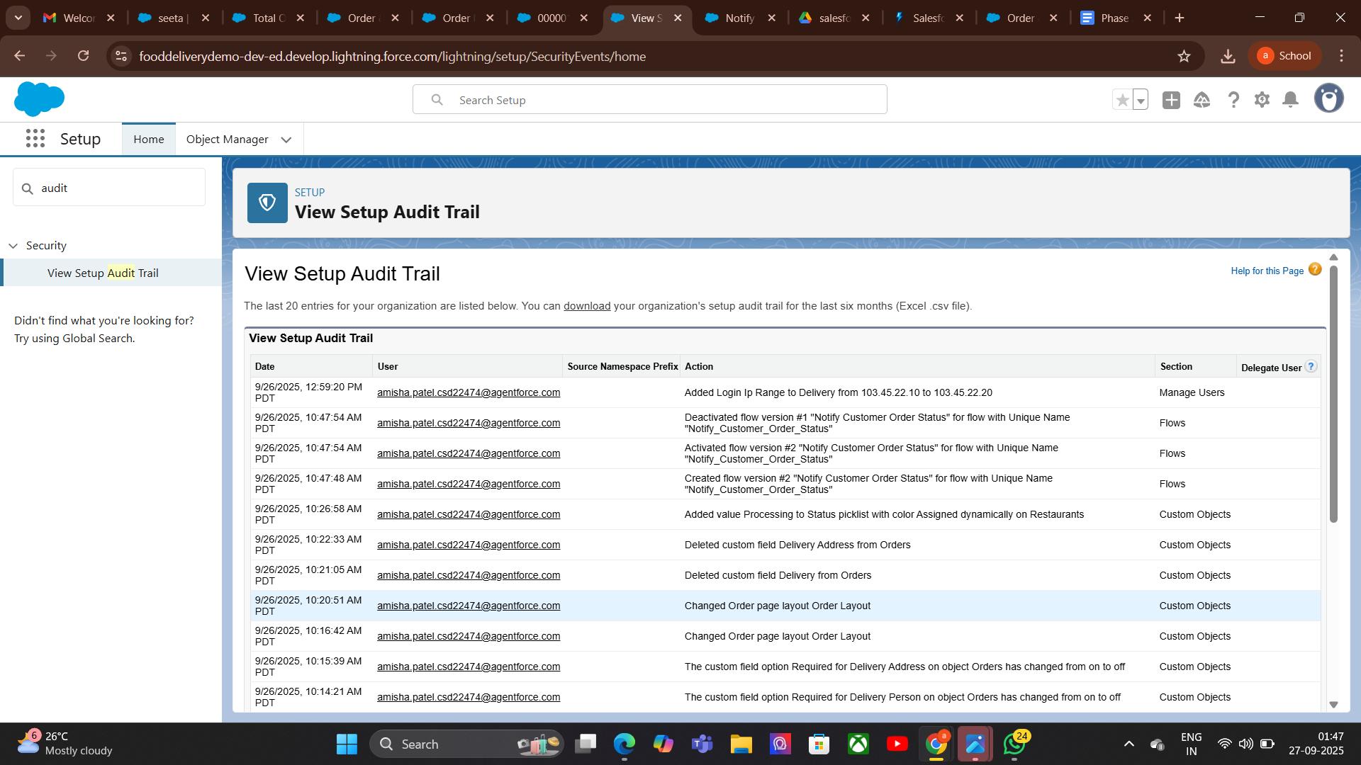

# **Phase 10: Final Presentation & Demo Day**

Goal : Successfully Complete the **FoodDelivery App Management**

1. **Pitch Presentation:**

### **Introduction-**

* Welcome & introduce the team.
* State the goal: *"To revolutionize food ordering with faster, smarter, and more convenient delivery."*
* Briefly state the problem:
  + Long delivery times
  + Limited restaurant choices
  + Poor tracking experience

### **Problem**

In today’s fast-paced world, customers face slow deliveries, limited restaurant choices, and poor order tracking.

### **Solution**

### smart Food Delivery app offering real-time tracking, wide restaurant selection, easy ordering, and secure payment.

### **Benefits**

Faster deliveries, higher customer satisfaction, increased orders for restaurants, and sustainable business growth.

**2. Demo Walkthrough:**

Walk through the app’s core functionality in a clear, logical order so the audience easily understands its features and benefits.

### Customer & Order Management

* Customer Onboarding: Demonstrate creating a new customer account with details such as name, address, contact number, and preferences.
* Placing an Order: Show how the customer browses restaurants, selects menu items, customizes them, and places an order.  
  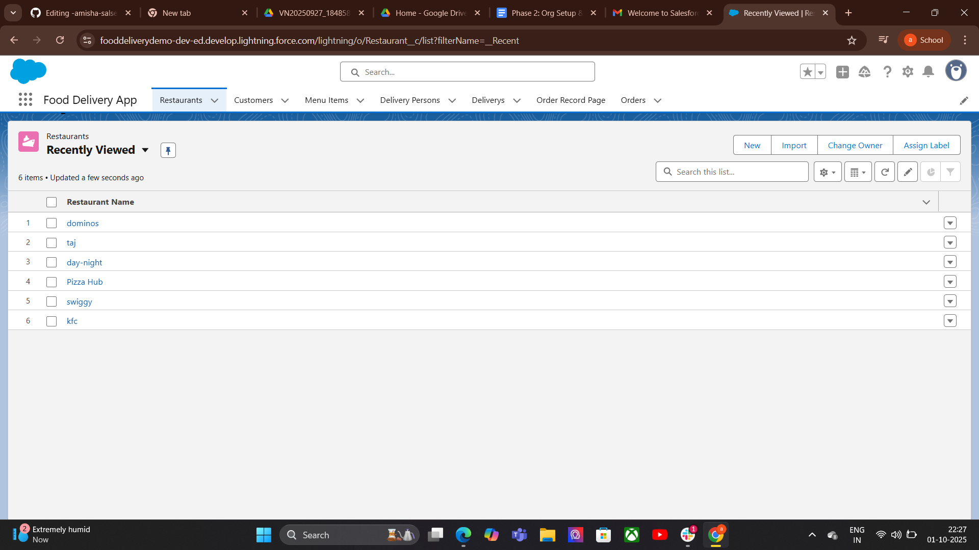
* Order Summary: Display order confirmation with details such as order number, estimated delivery time, and paymentsummary.

### **2. Real-Time Tracking & Notifications**

* Order Status Updates: Demonstrate how the app updates customers with real-time order statuses:  
  + Order Received
  + Preparing
  + Out for Delivery
  + Delivered
* Live Map Tracking: Show the delivery tracking map that updates location in real time.

### **3. Business Insights**

* Delivery Dashboard: Display a dashboard showing key metrics:
* Customer Insights: Show analytics like repeat customers, average order value, and ratings.

### **3.Feedback & Ratings**

* Demonstrate how customers can rate and review orders.
* Show how this feedback is stored and displayed for restaurant performance improvement.

**4. Handoff Documentation:**

### **. User Guide**

* Placing an Order: Search restaurants, choose items, customize orders, checkout, and payment.
* Order Tracking: Real-time updates and live map tracking.
* Order History & Feedback: View past orders and give ratings.
* Support: FAQs and contact details.

### **.Technical Guide**

A brief guide for future administrators to maintain and manage the app.

**Contents:**

* **System Overview:** Key modules — Customer Management, Order Management, Inventory, Delivery Tracking, Analytics.
* **Custom Objects:** Customers, Orders, Restaurants, Delivery.
* **Automation Rules:** Inventory updates and low-stock alerts.
* **Security Settings:** User roles and access permissions.
* **Dashboard:** Sales trends and key metrics.

**5. LinkedIn/Portfolio Project Showcase:**

### **1. Project Title- “*Food Delivery App – Real-Time Tracking & Automation”***

### **Problem Statement:** Customers face slow deliveries, limited restaurant choices, and poor tracking experiences in current food delivery systems.

### 

|  |
| --- |

### 